**ASSEMBLY GUIDE FOR LOCKER**

**Prepared By:**

**Tijmen Van Der Beek, Siquan Wang, Miren Patel, Xiaoang Zhang, Dazhou Liu**

*School of Engineering and Applied Sciences*

*University at Buffalo, The State University of New York*

*Spring 2021*

At first glance, looking at the locker parts might seem very complicated. However, it is not as complicated as it seems. This guide contains detailed steps along with pictures, wherever applicable, to make that process easy. Before you begin, make sure you keep the 12 V DeWalt Battery away during the assembly process. The reason for that is to ensure that you do not accidentally short the battery which can cause a fire hazard in some cases and can even permanently damage the components of the circuit.

Please follow the steps in order to assemble the locker.

1. For the first step, you will need this part. This part is the locker insert. The locker insert has a speaker glued onto it which has two wires connected to it. The purple wire is the POWER (+) and the black wire is the GROUND (-). There are pictures below for reference.

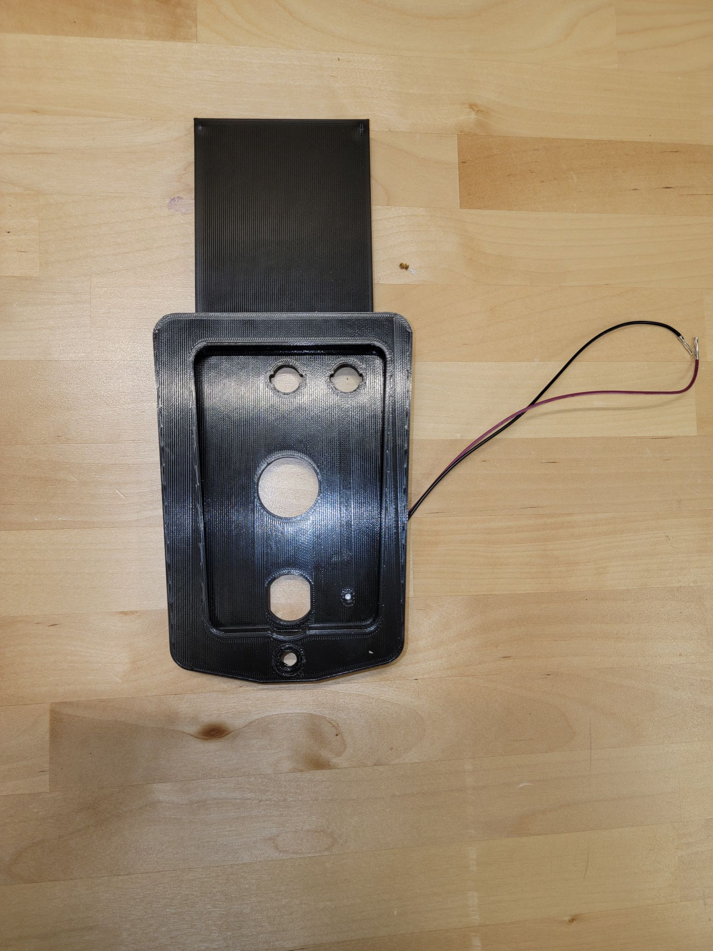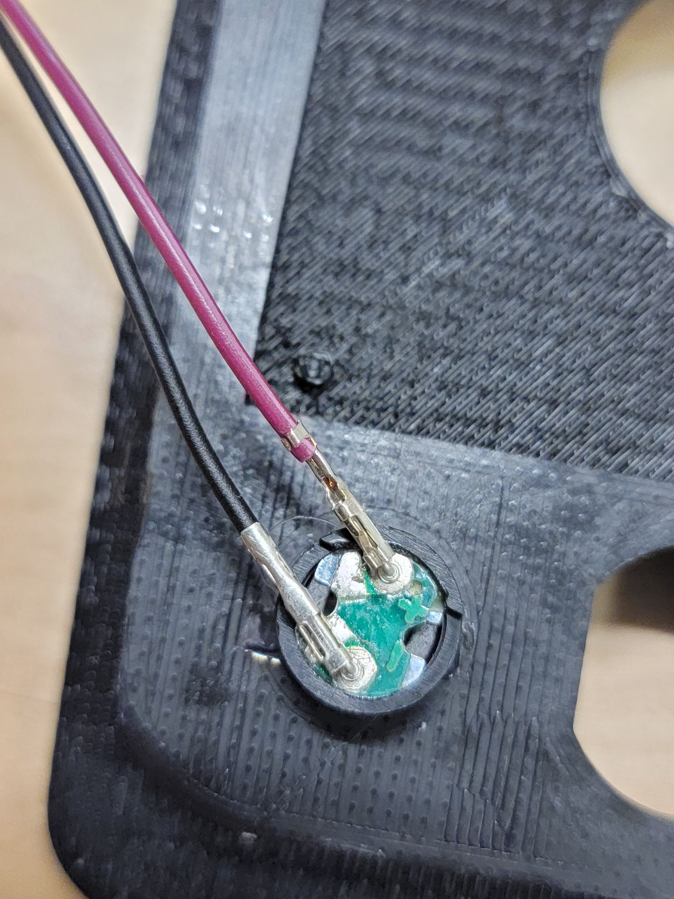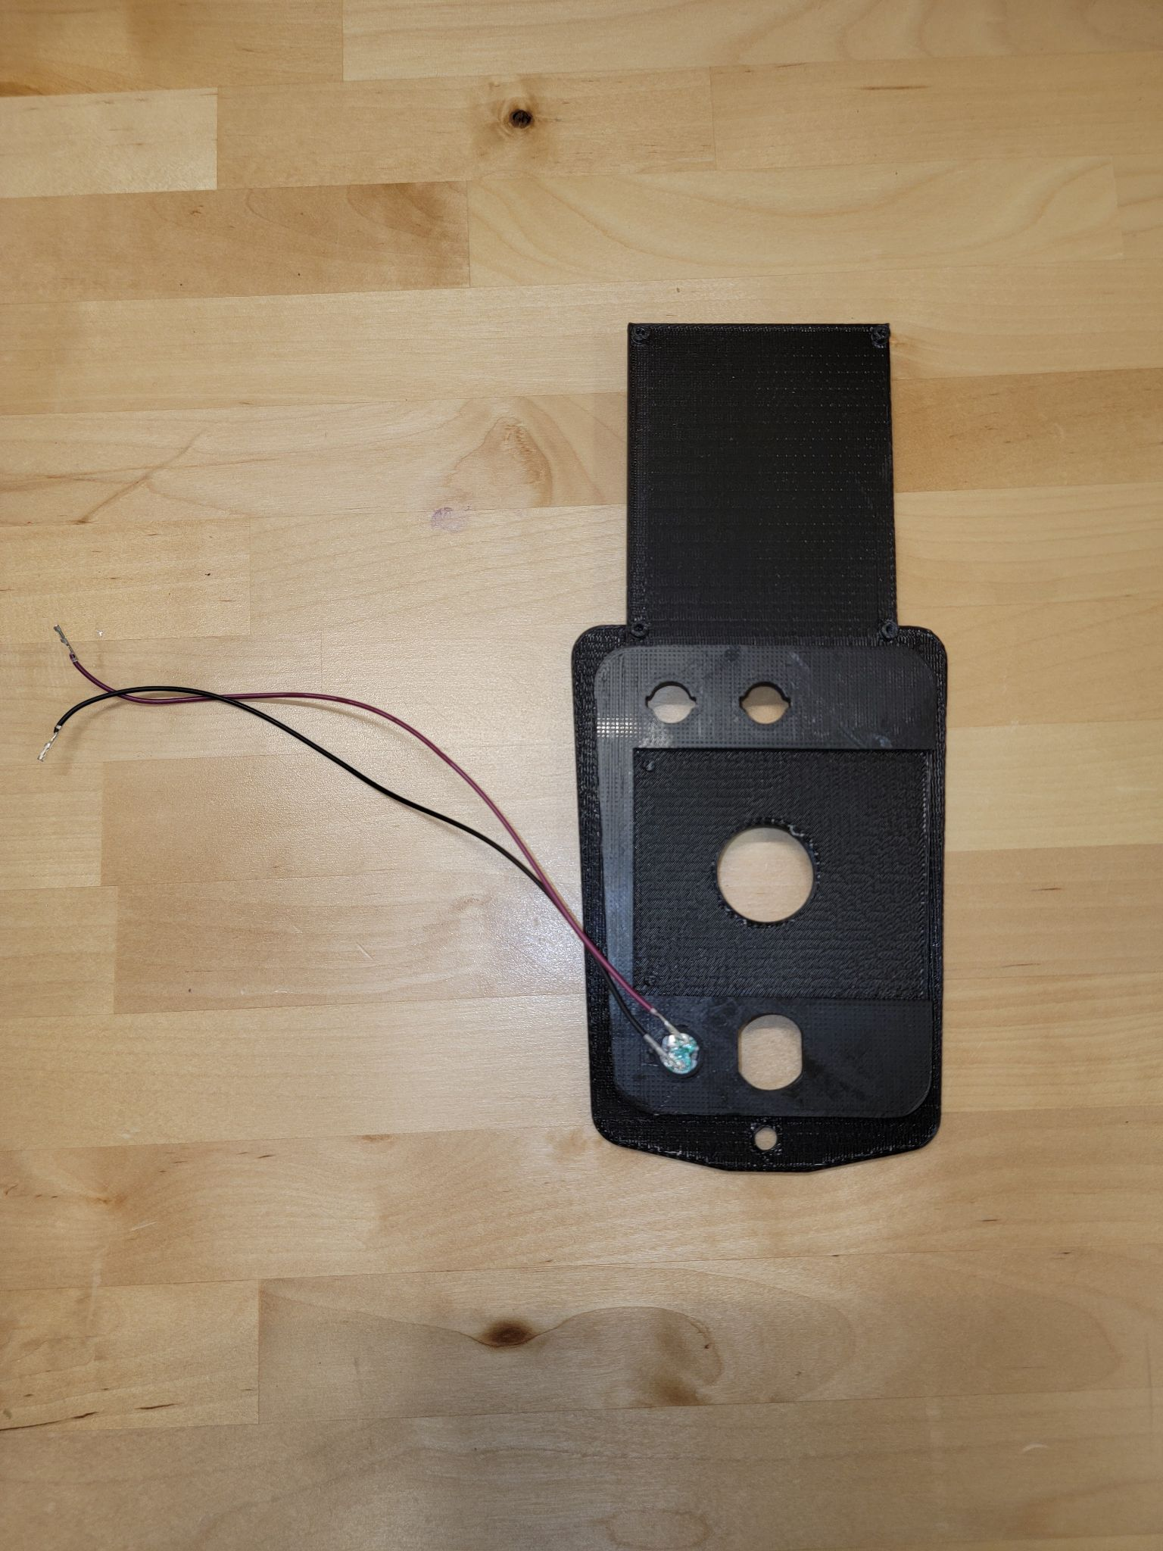

1. Then, get LED caps which look something like these.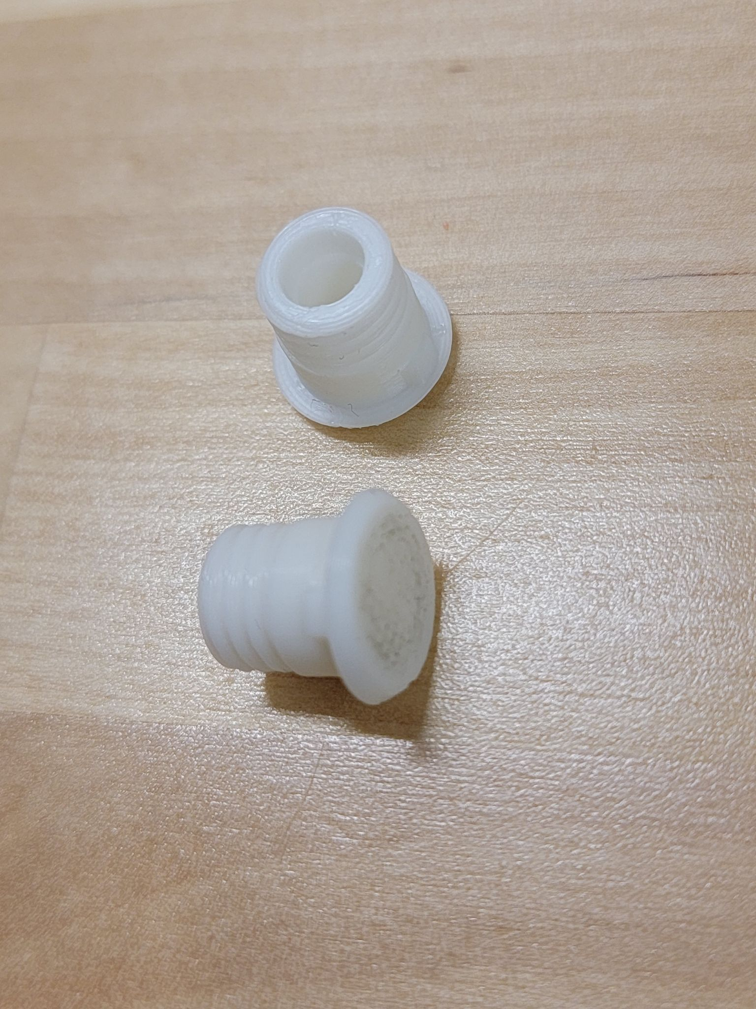
2. After you get them, insert them onto the holes on the locker insert as shown in the picture.

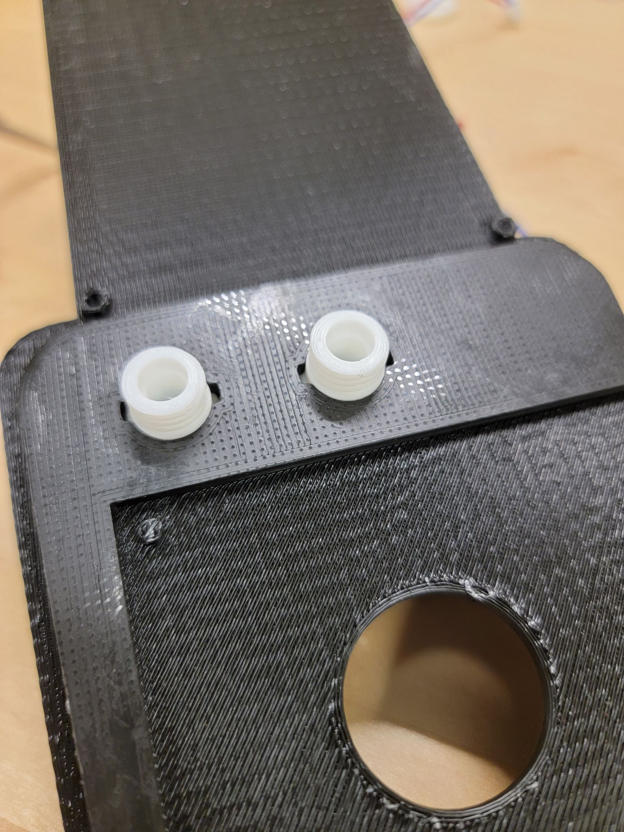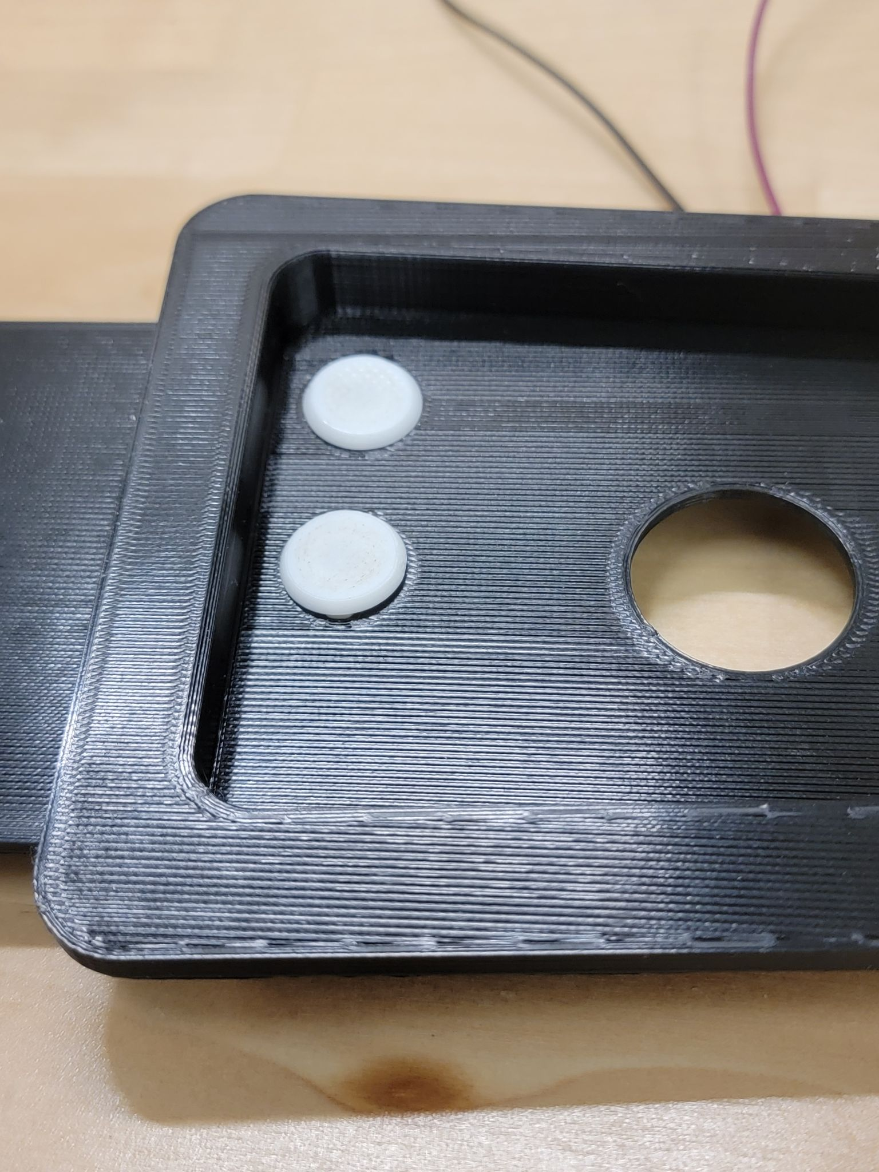

1. Once you put the LED caps on, put the LEDs on. In the picture below, they are glued on so that they stay in place. Then, nuts were used on the opposite end of the LED caps to make sure they stay in place. You may need to use pliers to tighten them so that the LED caps are firmly attached.

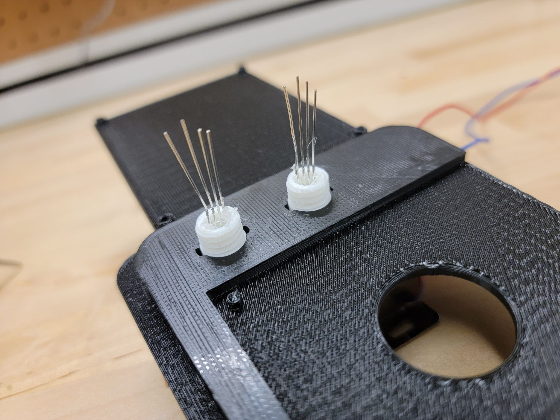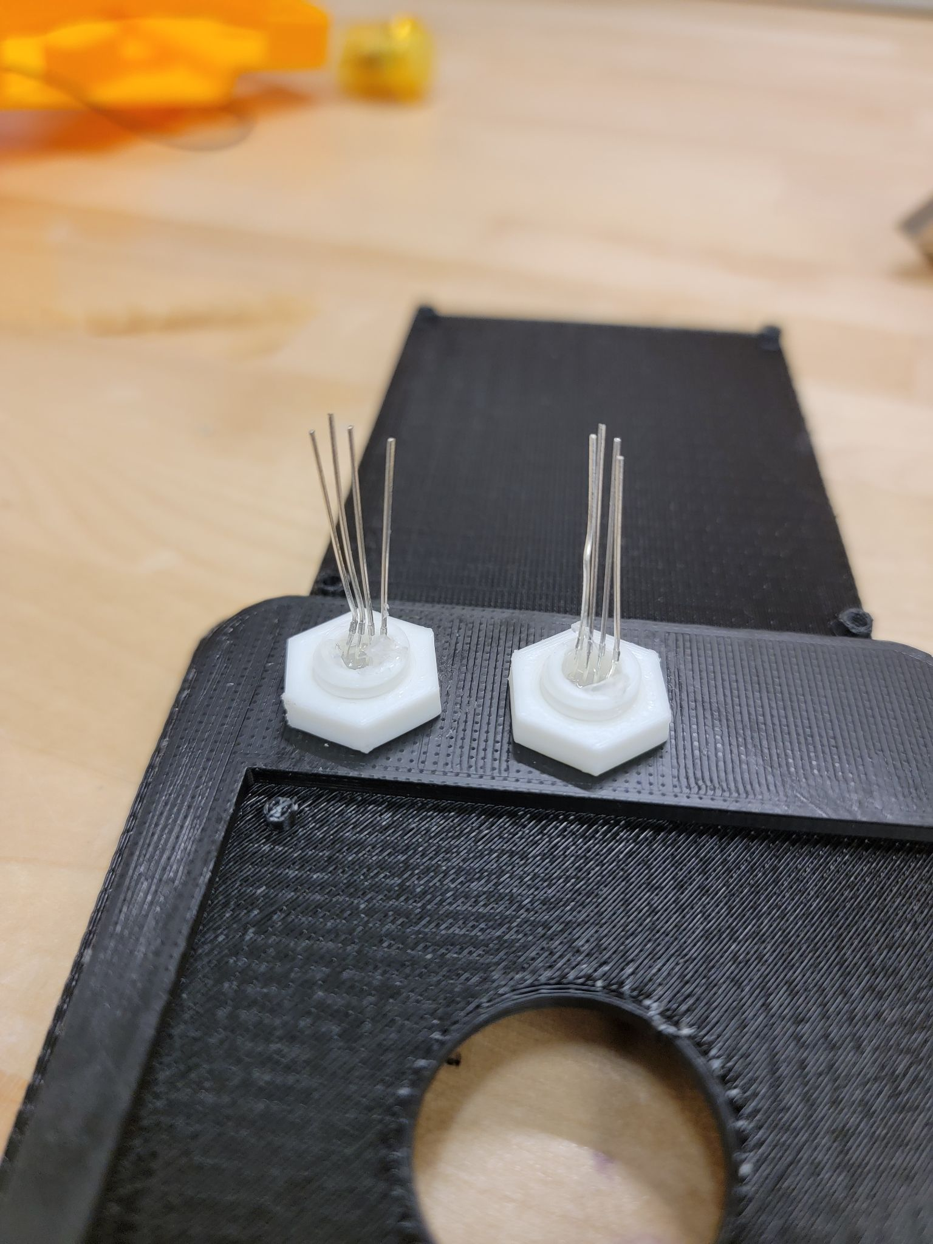

1. After you do that, take the circuit (green board with wires) and place it on top of the locker insert as shown in the picture below. Make sure you line up the four holes so that the circuit can be screwed onto the locker insert. Then screw the circuit onto the insert using four M3-0.5 x 6 mm screws. Make sure the board is facing the right direction.

**Note:** With some designs of the circuit, you might only be able to screw in three screws and that is totally fine as long as the circuit board is stable and secure onto the insert.

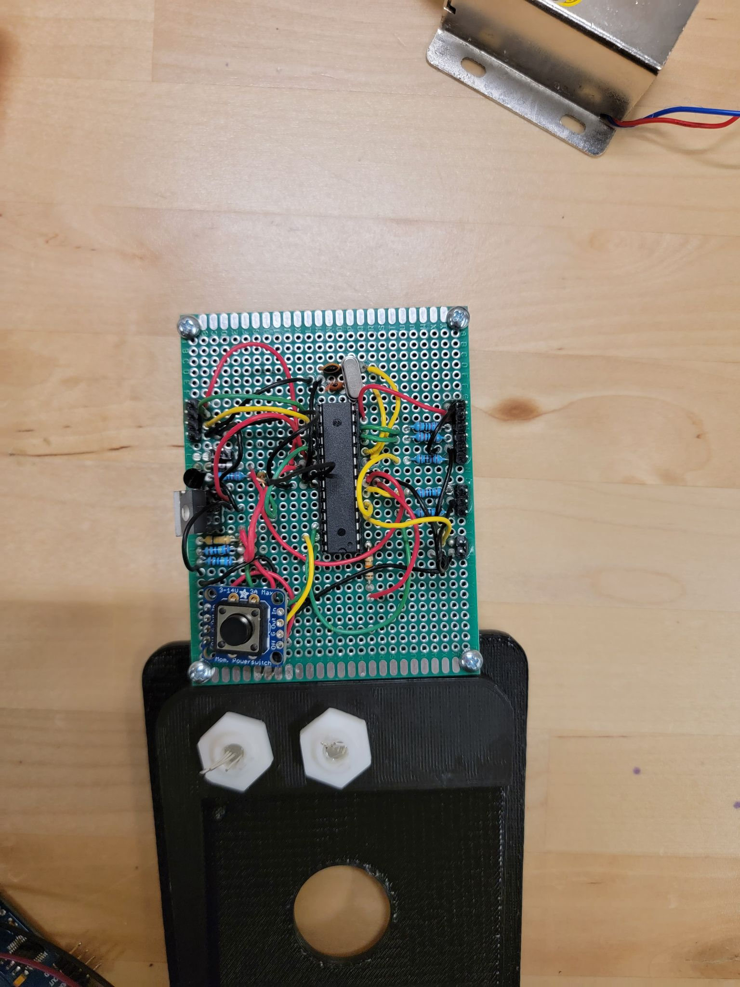

1. Shown below is the front and the back picture of the insert case. This where the battery mount will be screwed onto.

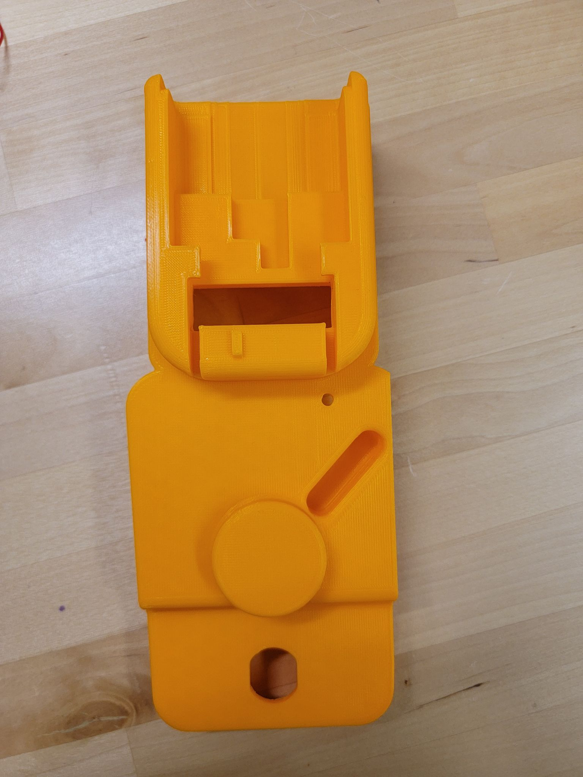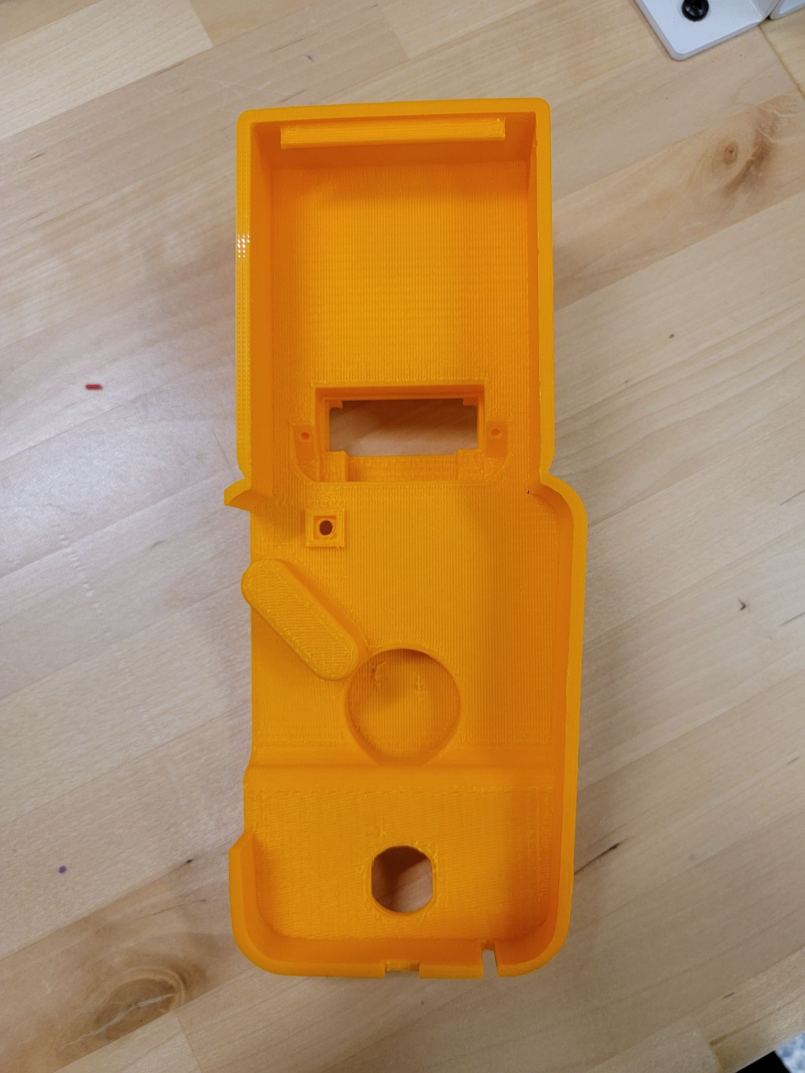

1. Take the battery mount (shown on the left below) and screw it on the back of the locker insert case using two M3-0.5 x 8 mm screws as shown in the picture on the right below.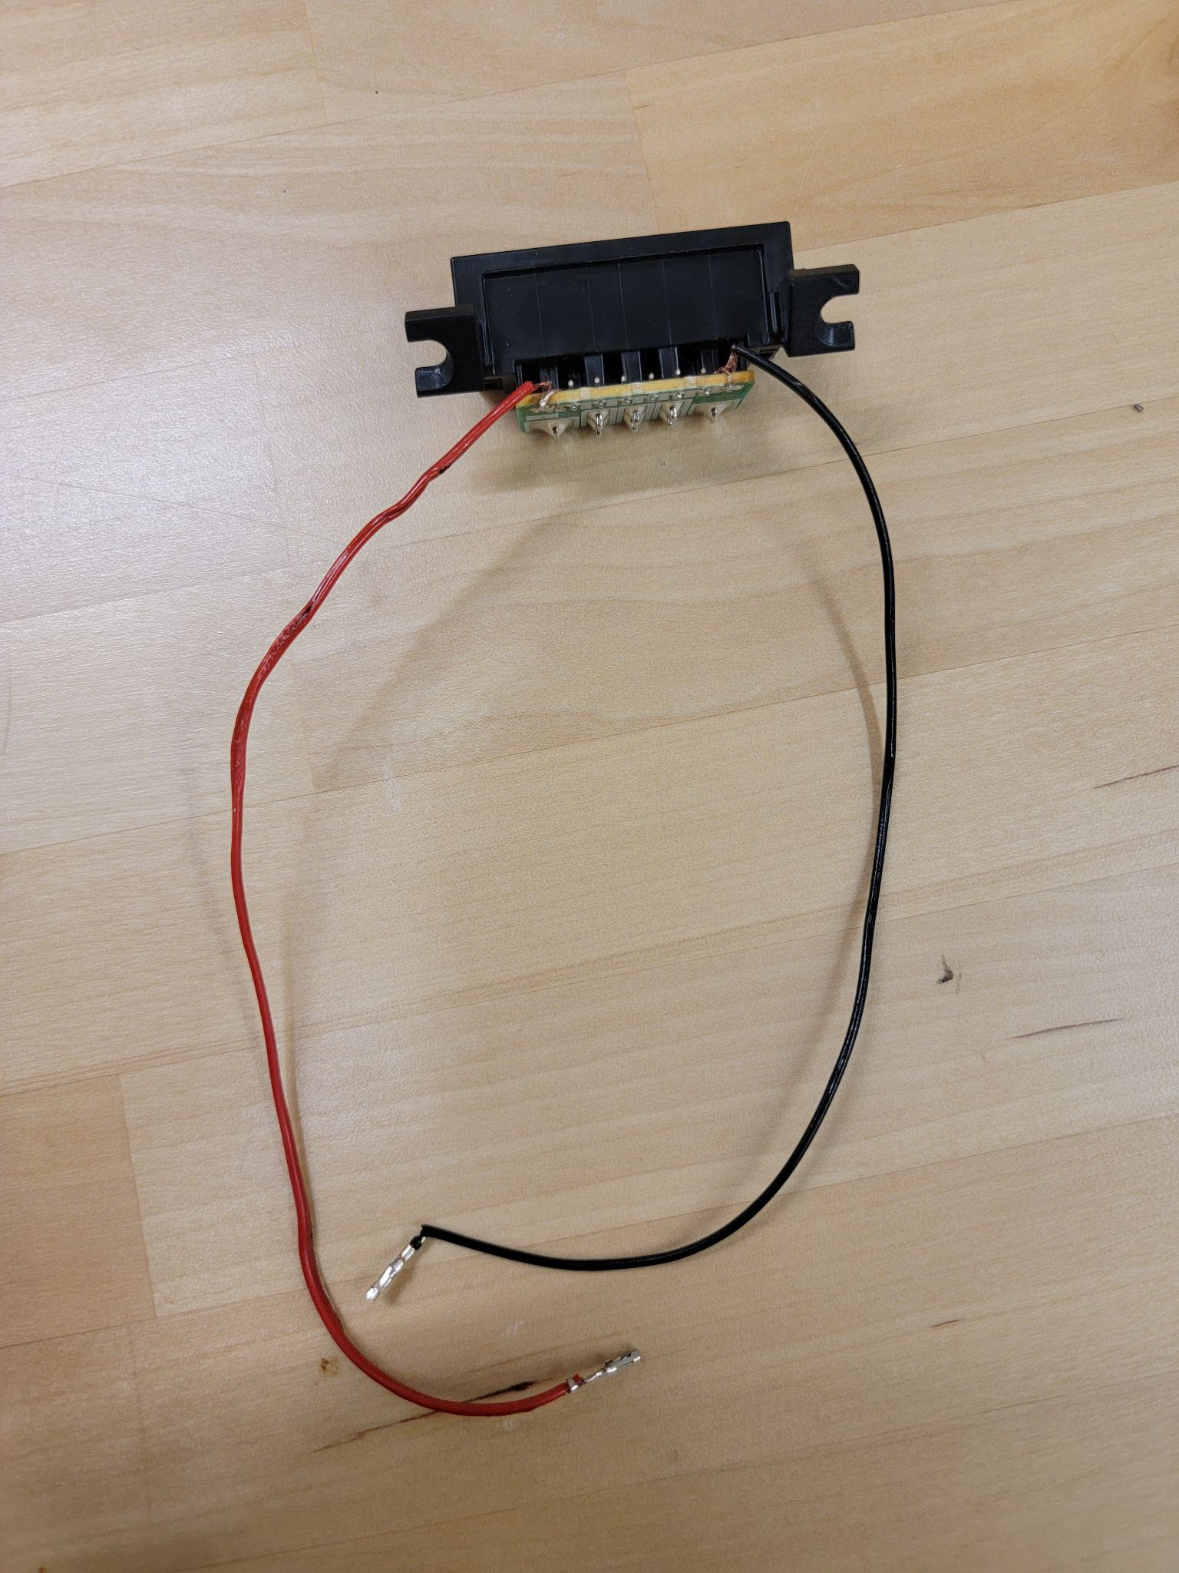

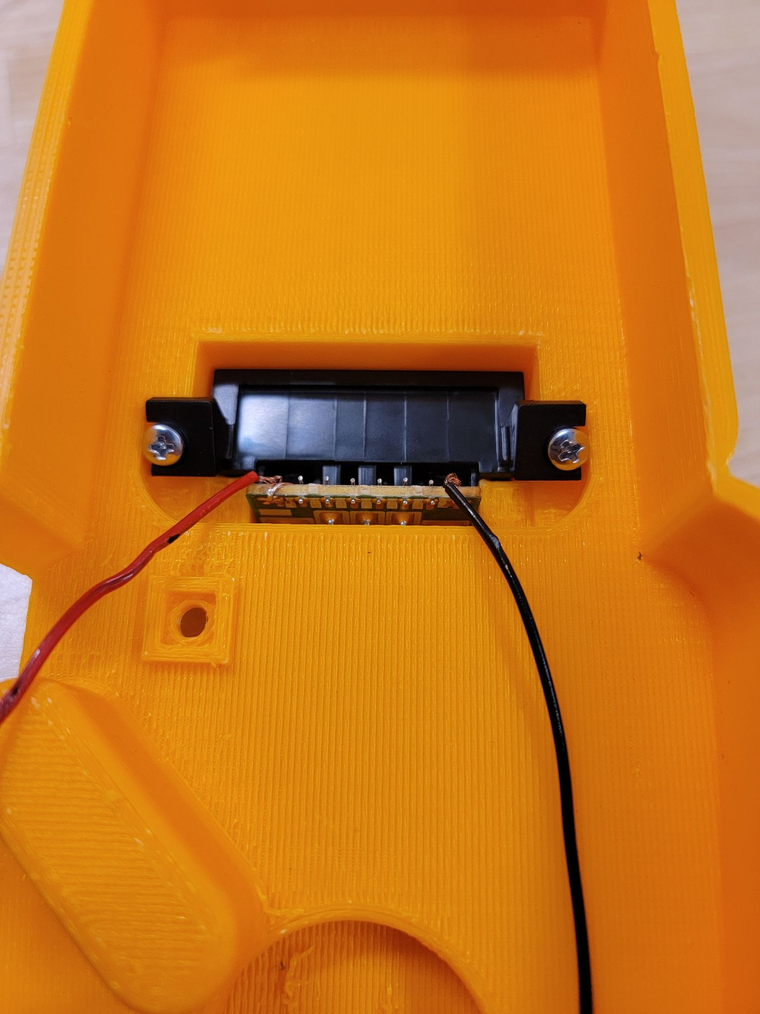

1. After you do that, it should look like this from the front.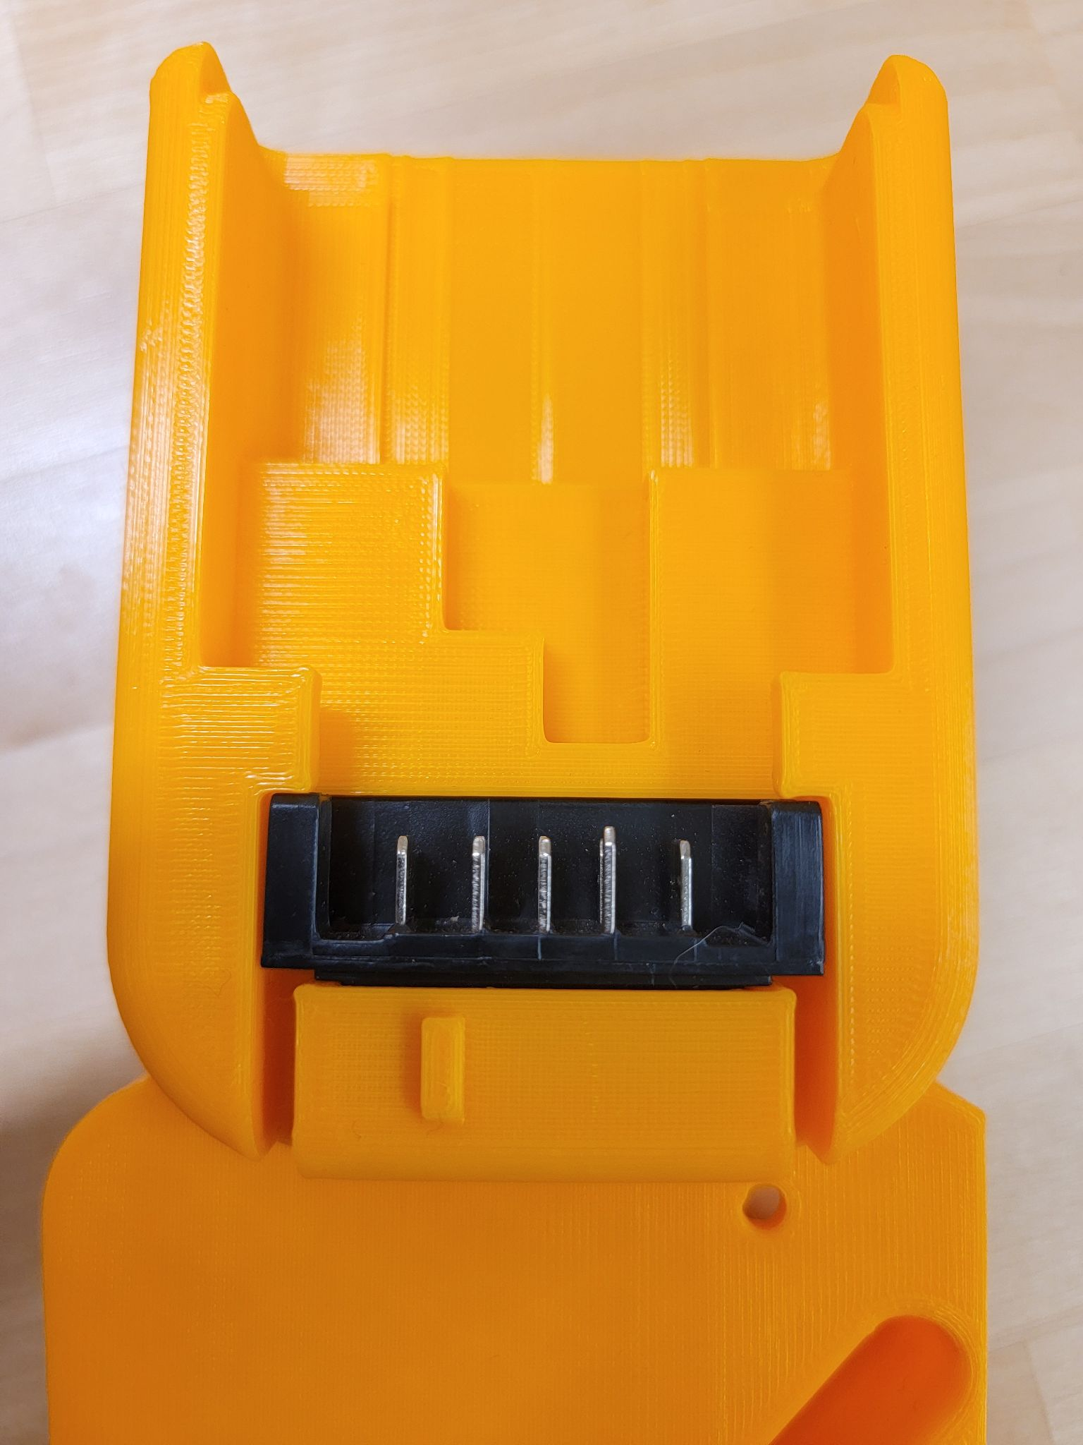
2. On the back of the insert case, there is a small hole to the left of the battery mount. Glue the reset button (shown on the left) on that hole. Be careful to only add glue to the side of the hole so that the sides of the button stick and not the whole button. Make sure that the button is stuck well and is secure in that hole. This is to ensure that it can still be pressed from the other side of the hole using a thin object. It is a reset button and can clear all the tags leaving the locker useless. Therefore, it must only be accessed by the faculty.

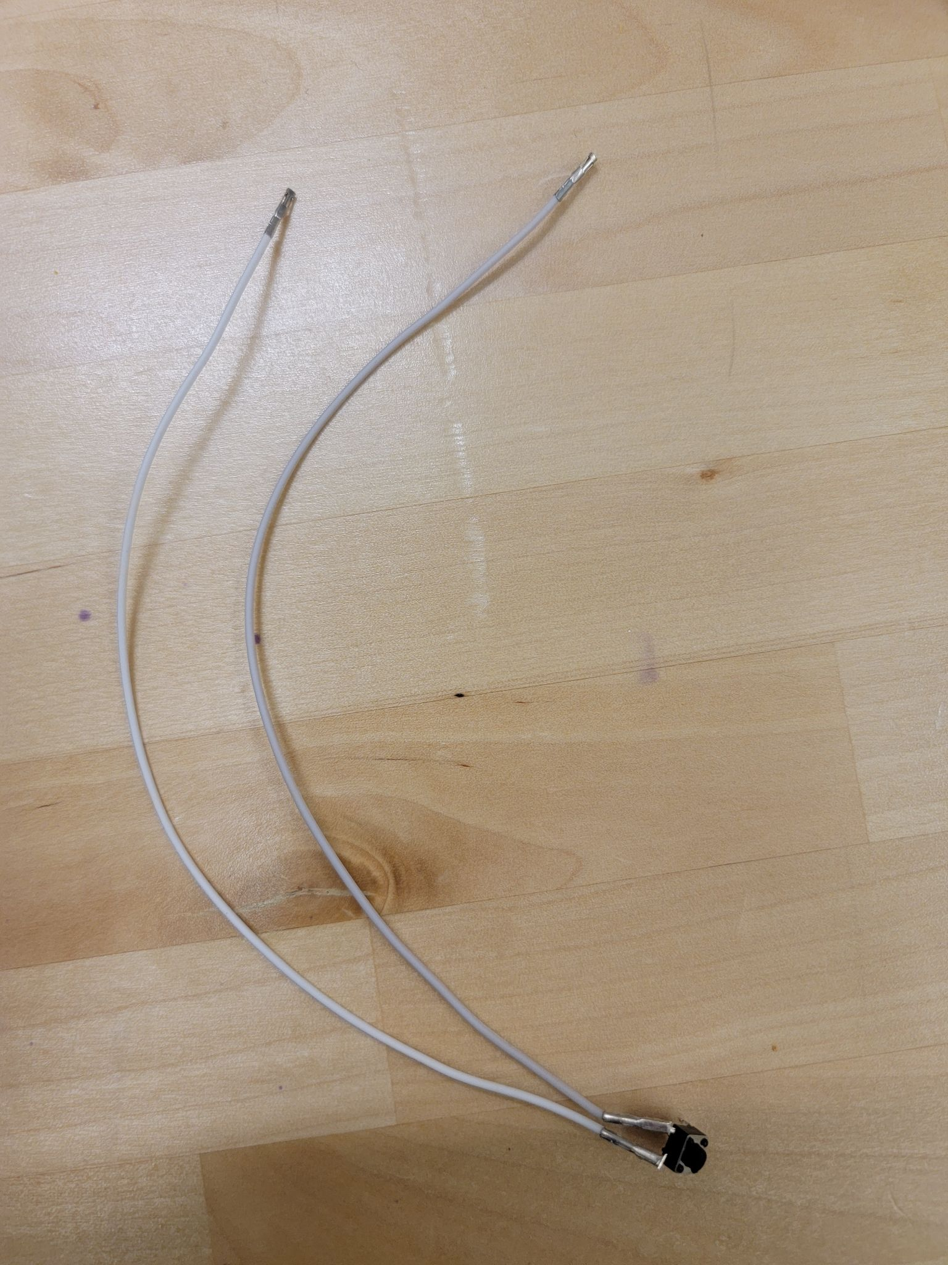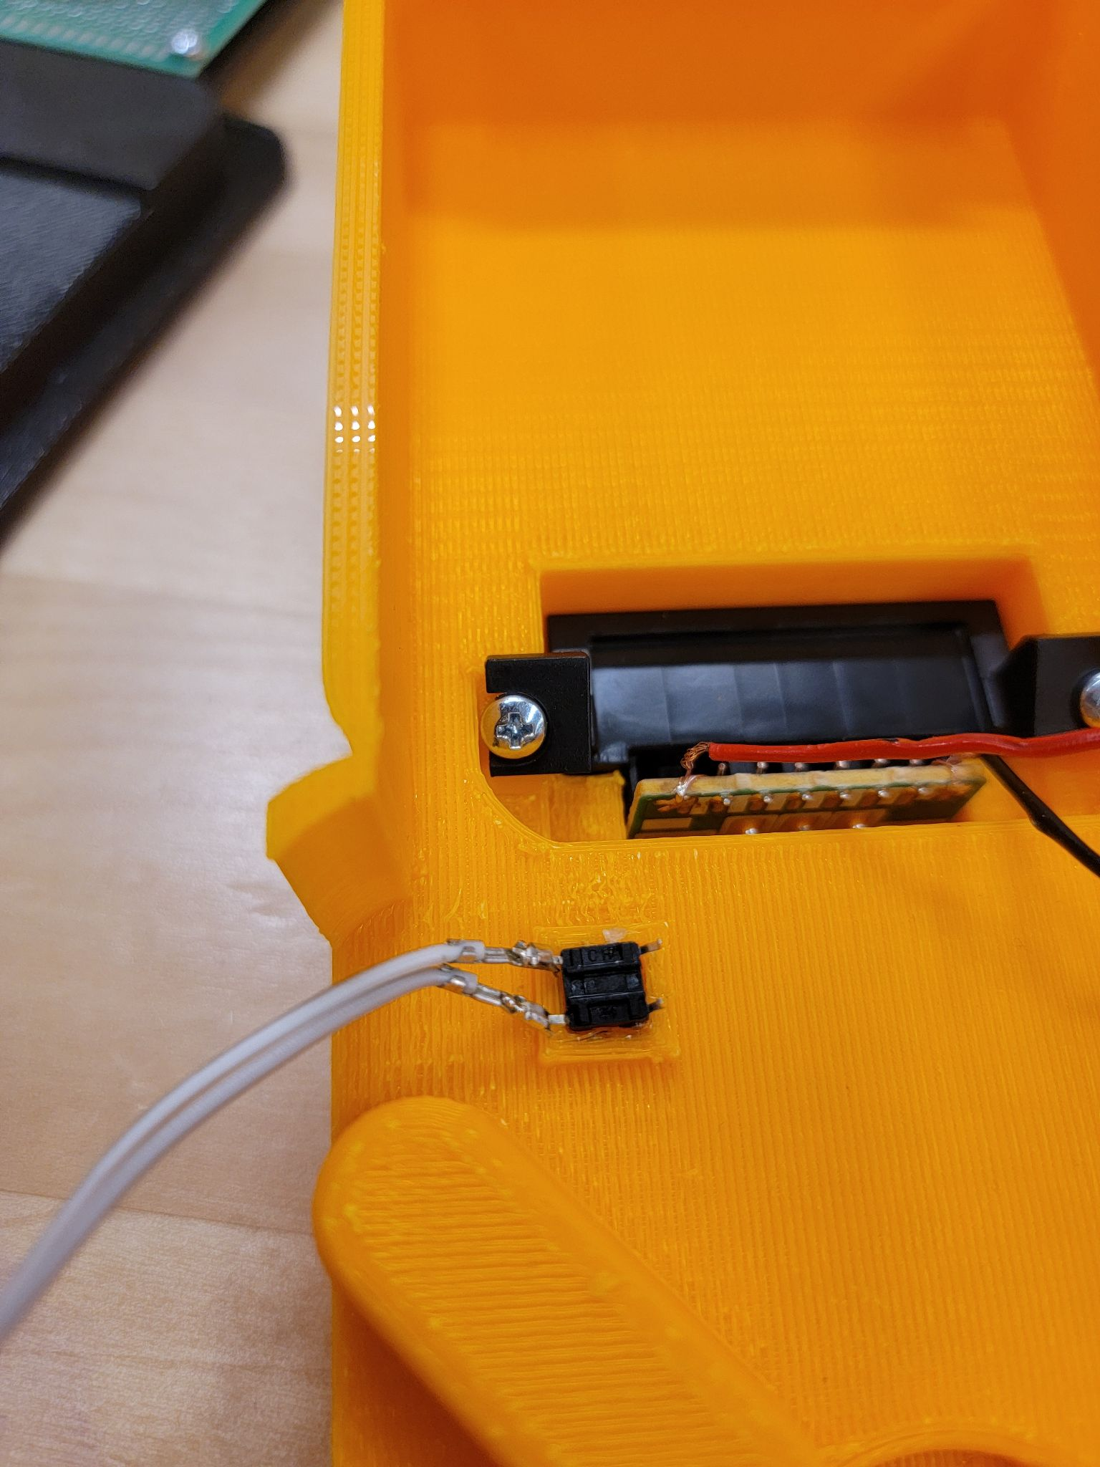

1. Now comes the most complicated part which is assembling the circuit. Take the two wires from the reset button and put it on the bottom two right pins on the circuit board as shown in the picture below. Order does not matter for these particular pins.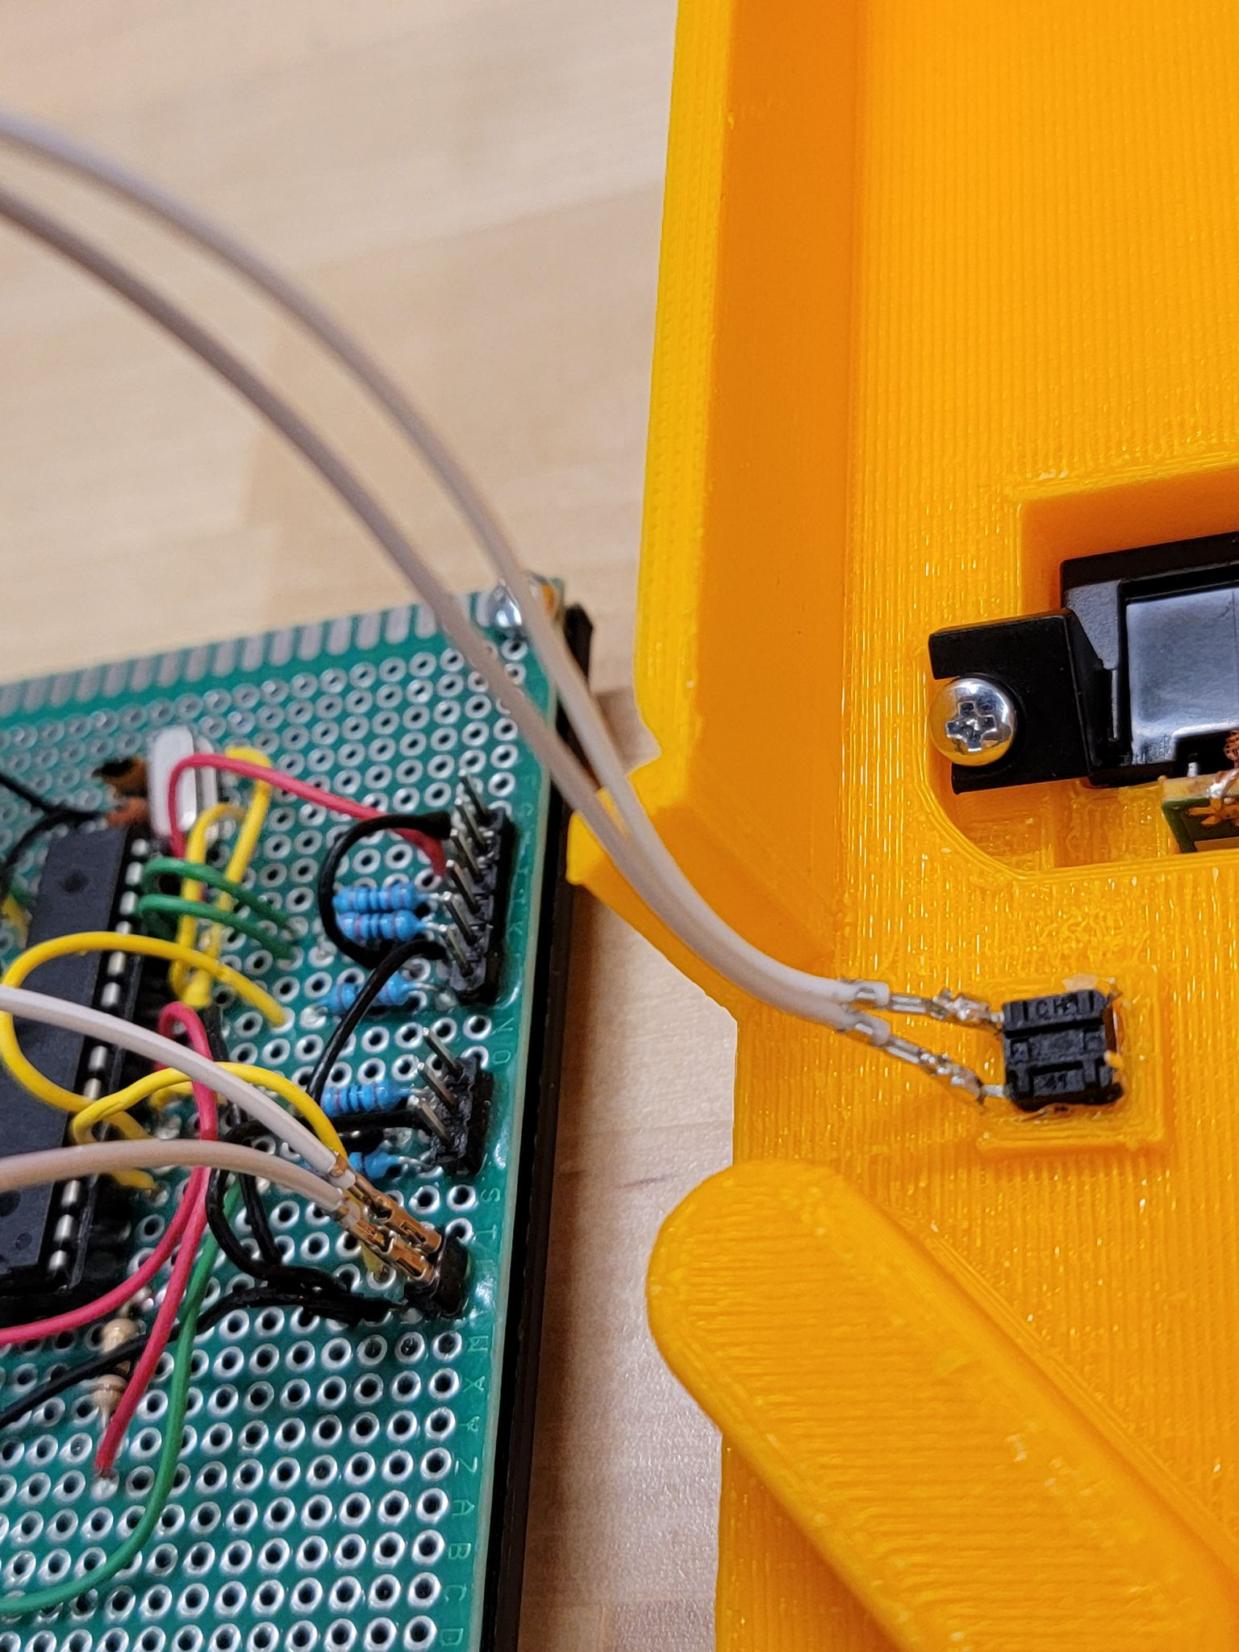

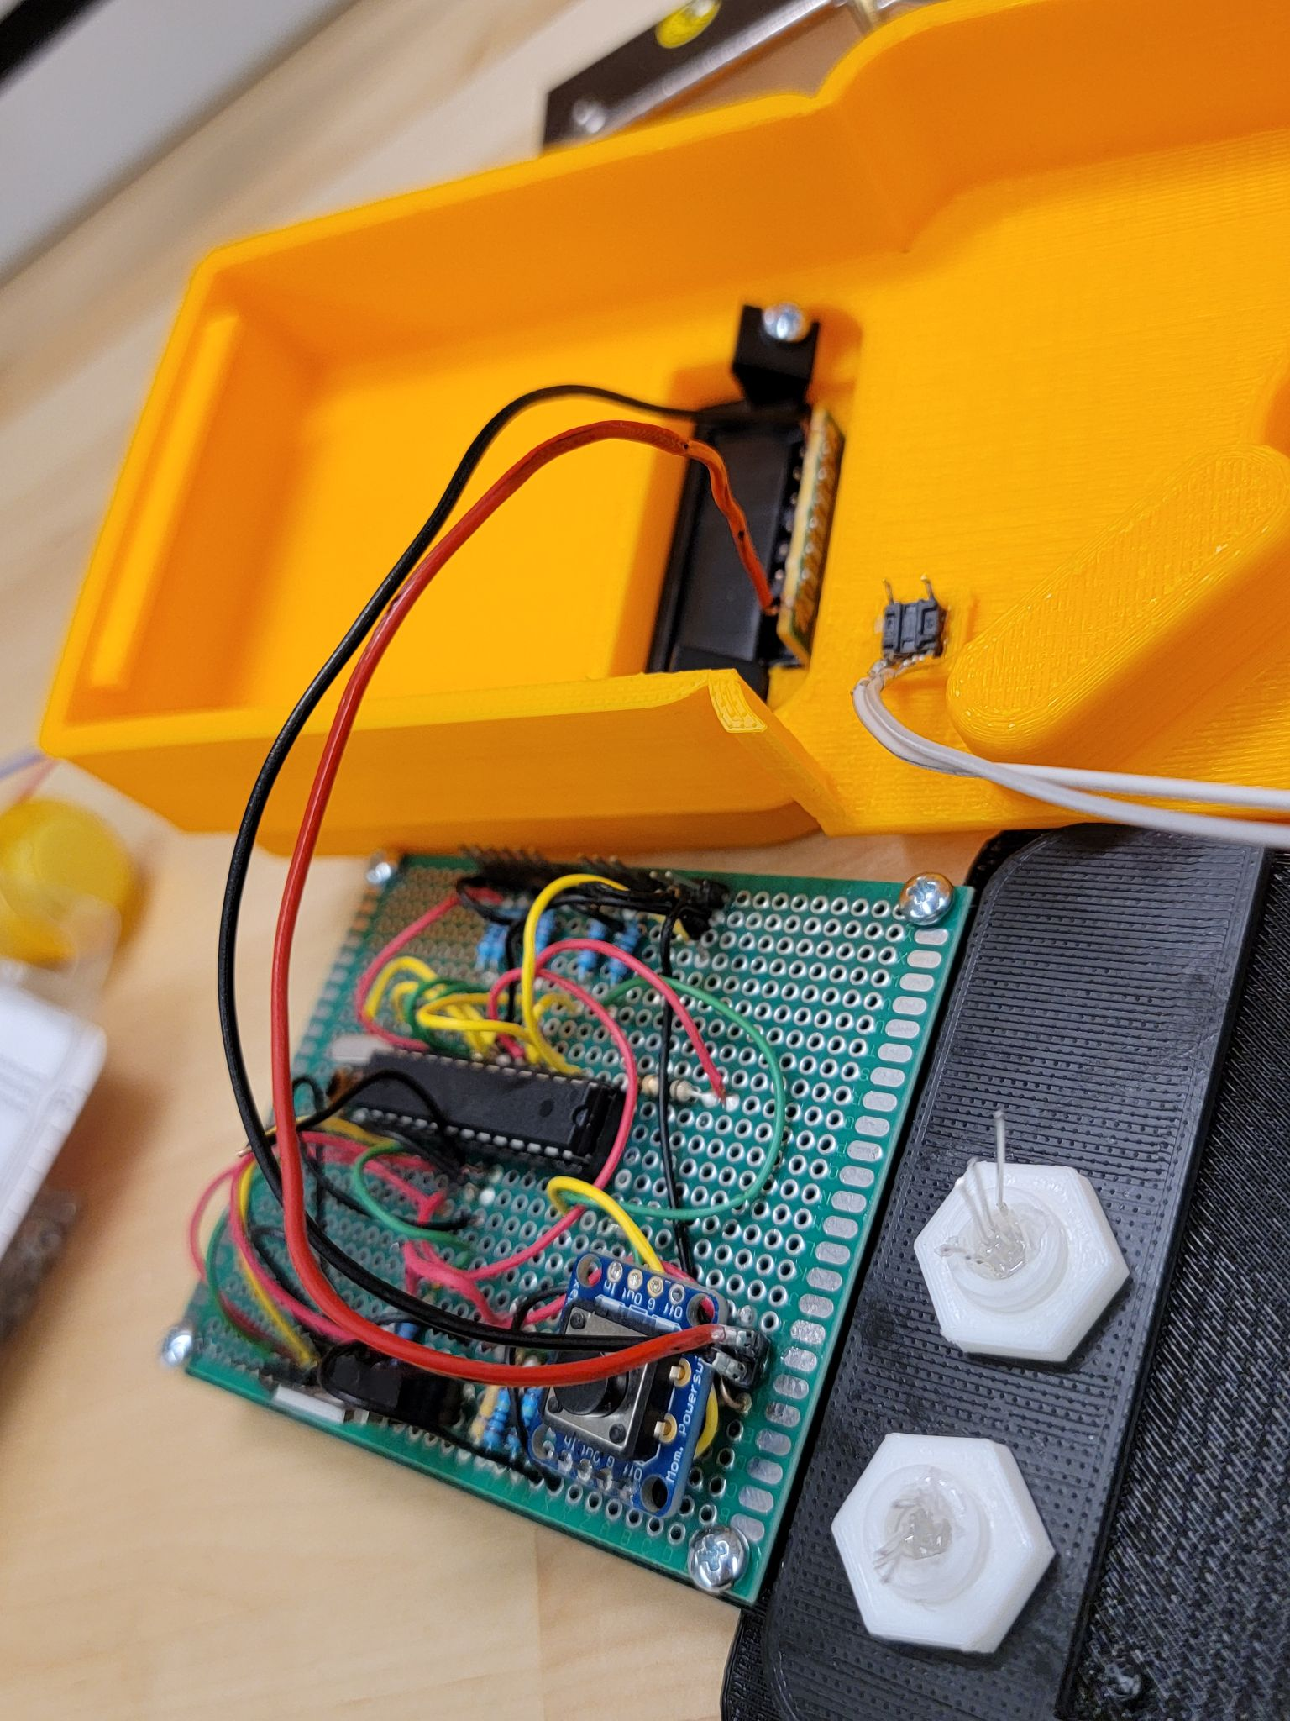

1. Then, take the two wires from the battery mount and put them on the two pins on the bottom left of the board. Be careful while configuring these two wires because it is very IMPORTANT that the cables are in the right position or it will damage the circuit board. The red wire is the POWER and goes to the right pin. The black wire is the GROUND and goes to the left pin as shown in the picture.

**Note:** the reset button seems like it was unplugged in the picture but that was only to make sure the steps were clear enough to make the assembly process easier. If we did not do that, the circuit would look covered in wires and would be very difficult to follow.

1. On the right LED (this LED indicates the RFID tag status), put the wires as shown below. These are color coded so make sure they are in the correct order of Red, Black, Green, and Blue. These wires are then attached to the pins on the right side of the circuit board as shown in the picture below in the correct order as well (Red, Black, Green, and Blue).

**Note:** You can hot glue the wires to the LED because sometimes the wires are loose and can get disconnected while assembling of the circuit.

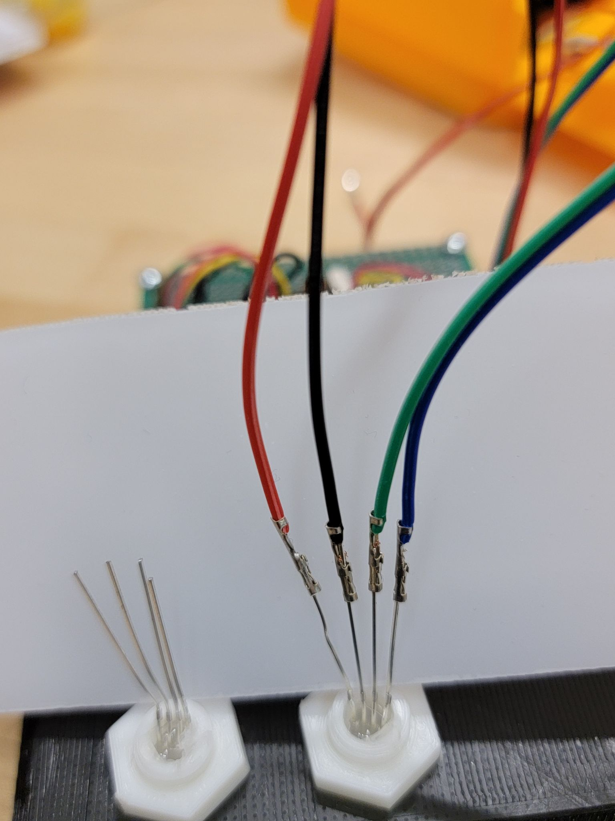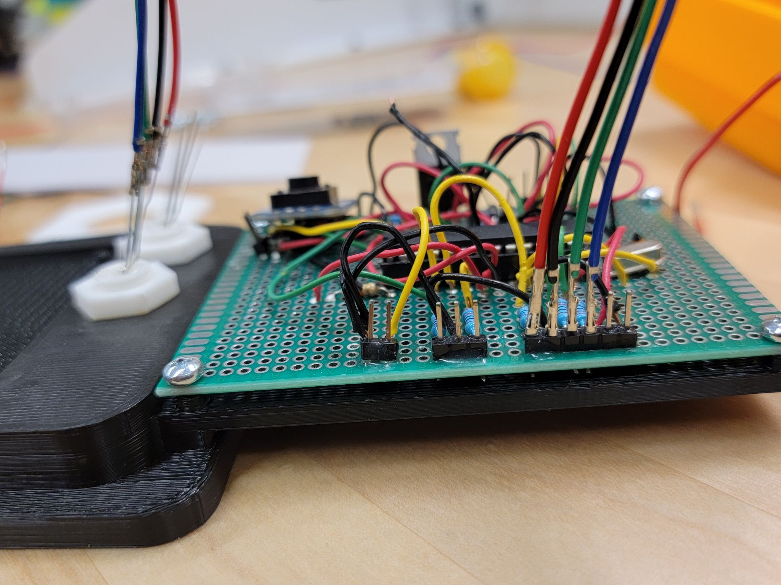

1. On the left LED (this LED indicates battery status), put the wires according to the picture shown on the left below. Then connect the other ends of those wires to the right middle pins of the circuit board as shown in the picture right below. Make sure they are in the correct order of green, black, and red from left to right.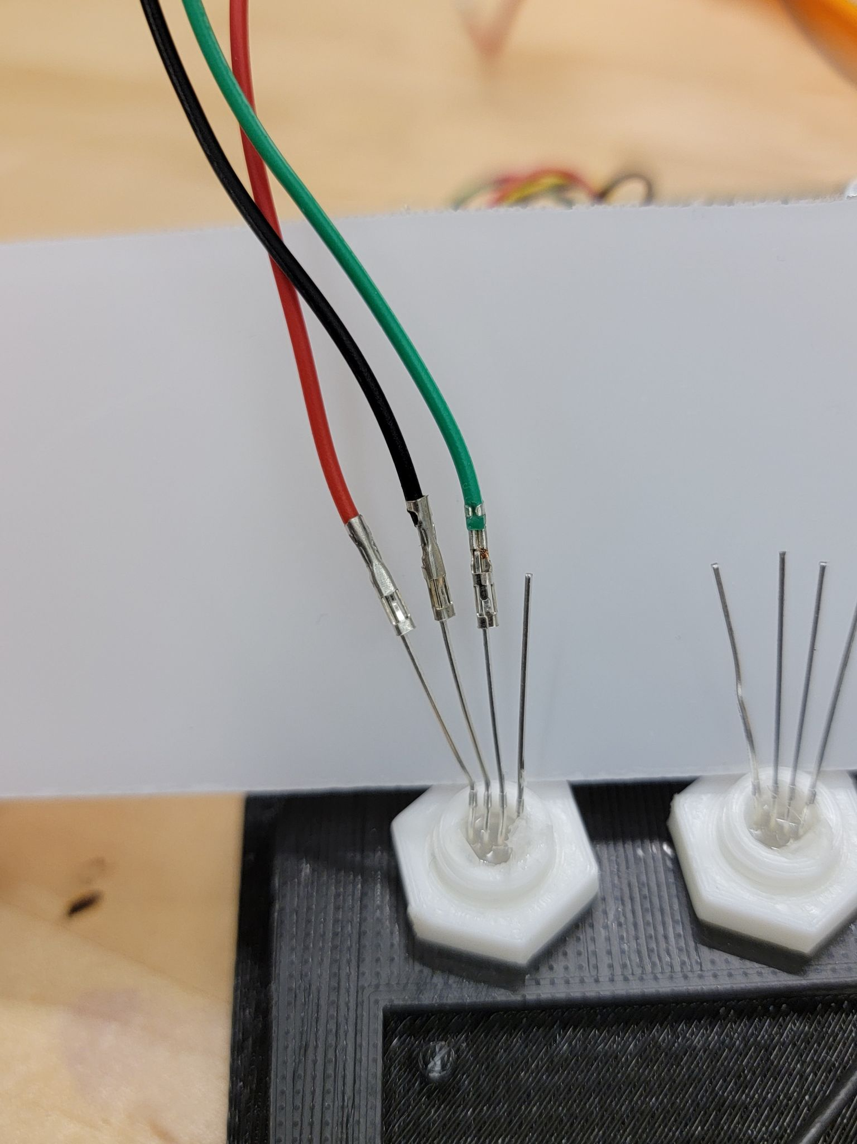

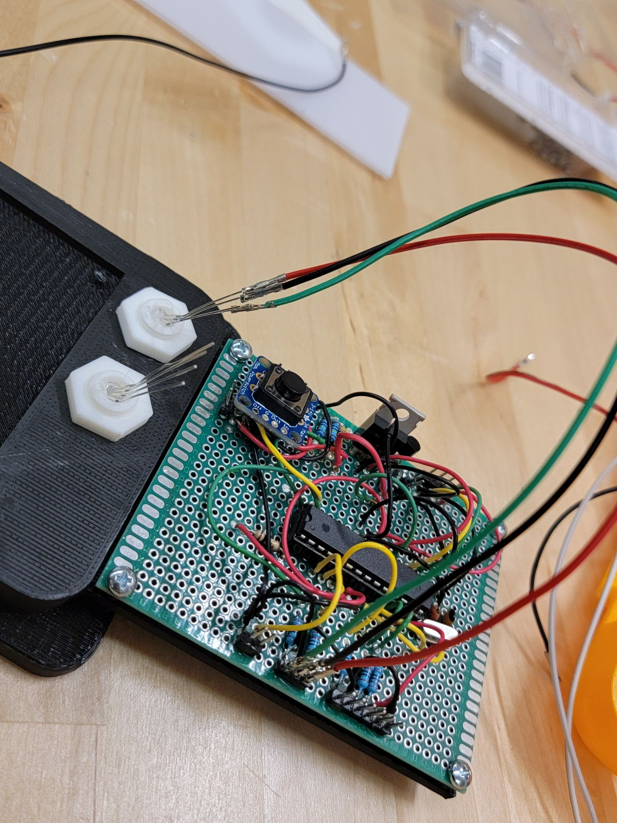

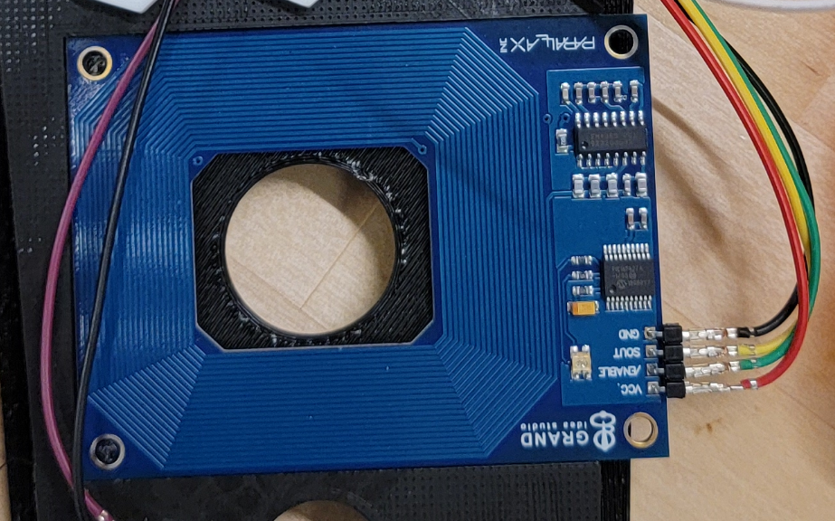

1. Then take the RFID module (one in blue with a square cut-out) and place it onto the insert. Then connect four wires in the correct order. VCC is red, ENABLE is green, SOUT is yellow and GND is red. It is shown on the picture on the right. Then connect the other ends of those wires to the left top of the circuit board as shown in the picture below in the following order of red, green, yellow and black.

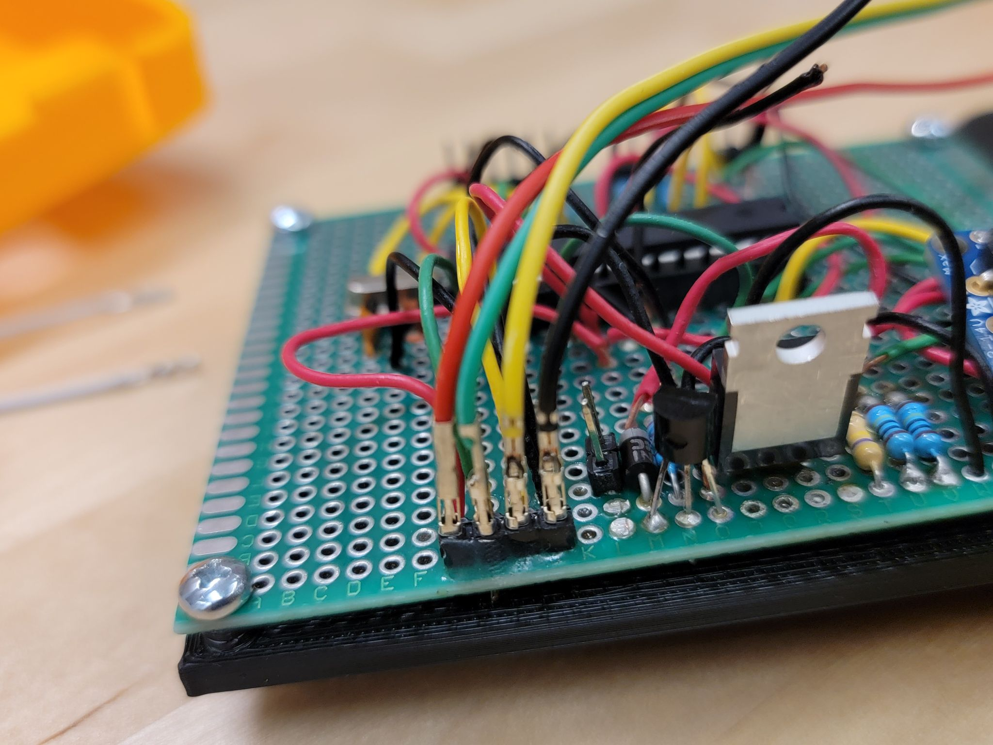

1. Take the solenoid that looks like the silver object on the left side of the picture and connect it to the two pins as shown. For reference, it is right below the pins you connected to in the previous step. For this component, the order does not matter as long as both the pins are connected.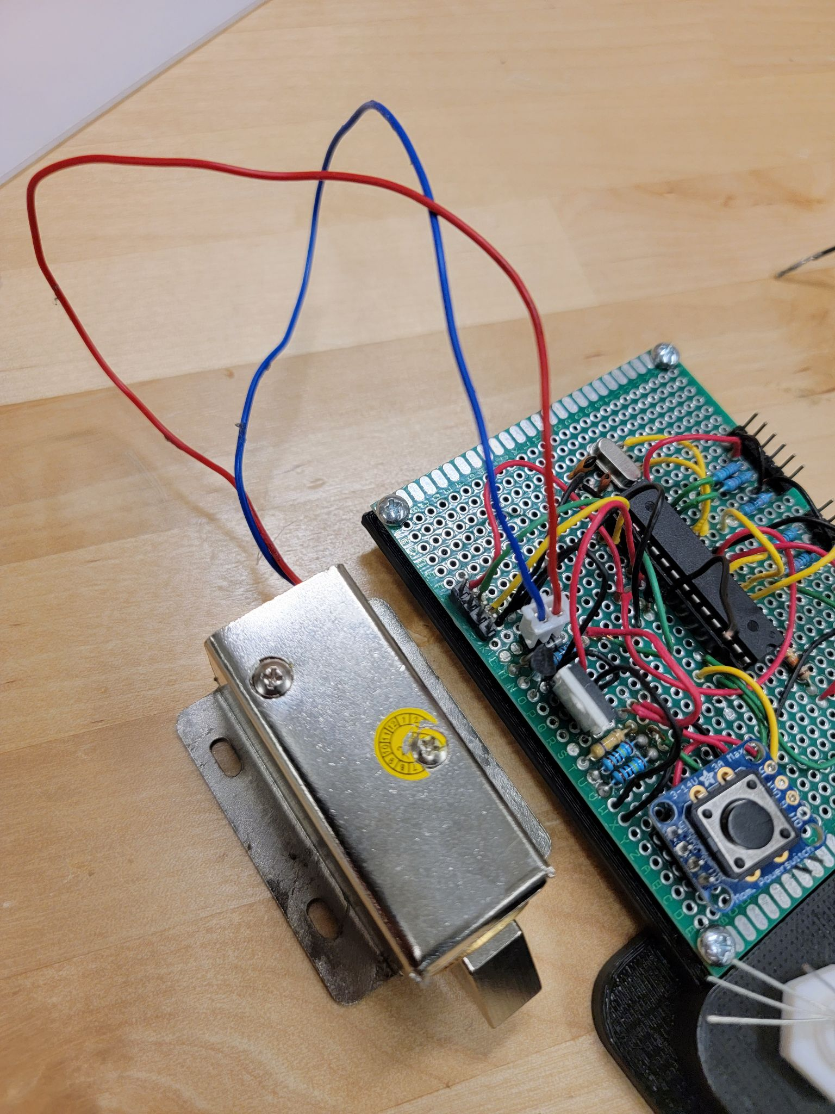
2. After connecting all the wires, the circuit should look like the picture shown below. If that looks confusing, look at the schematic on the next below to make sure you got the circuit right. This is very important because the locker’s functionality depends on it.

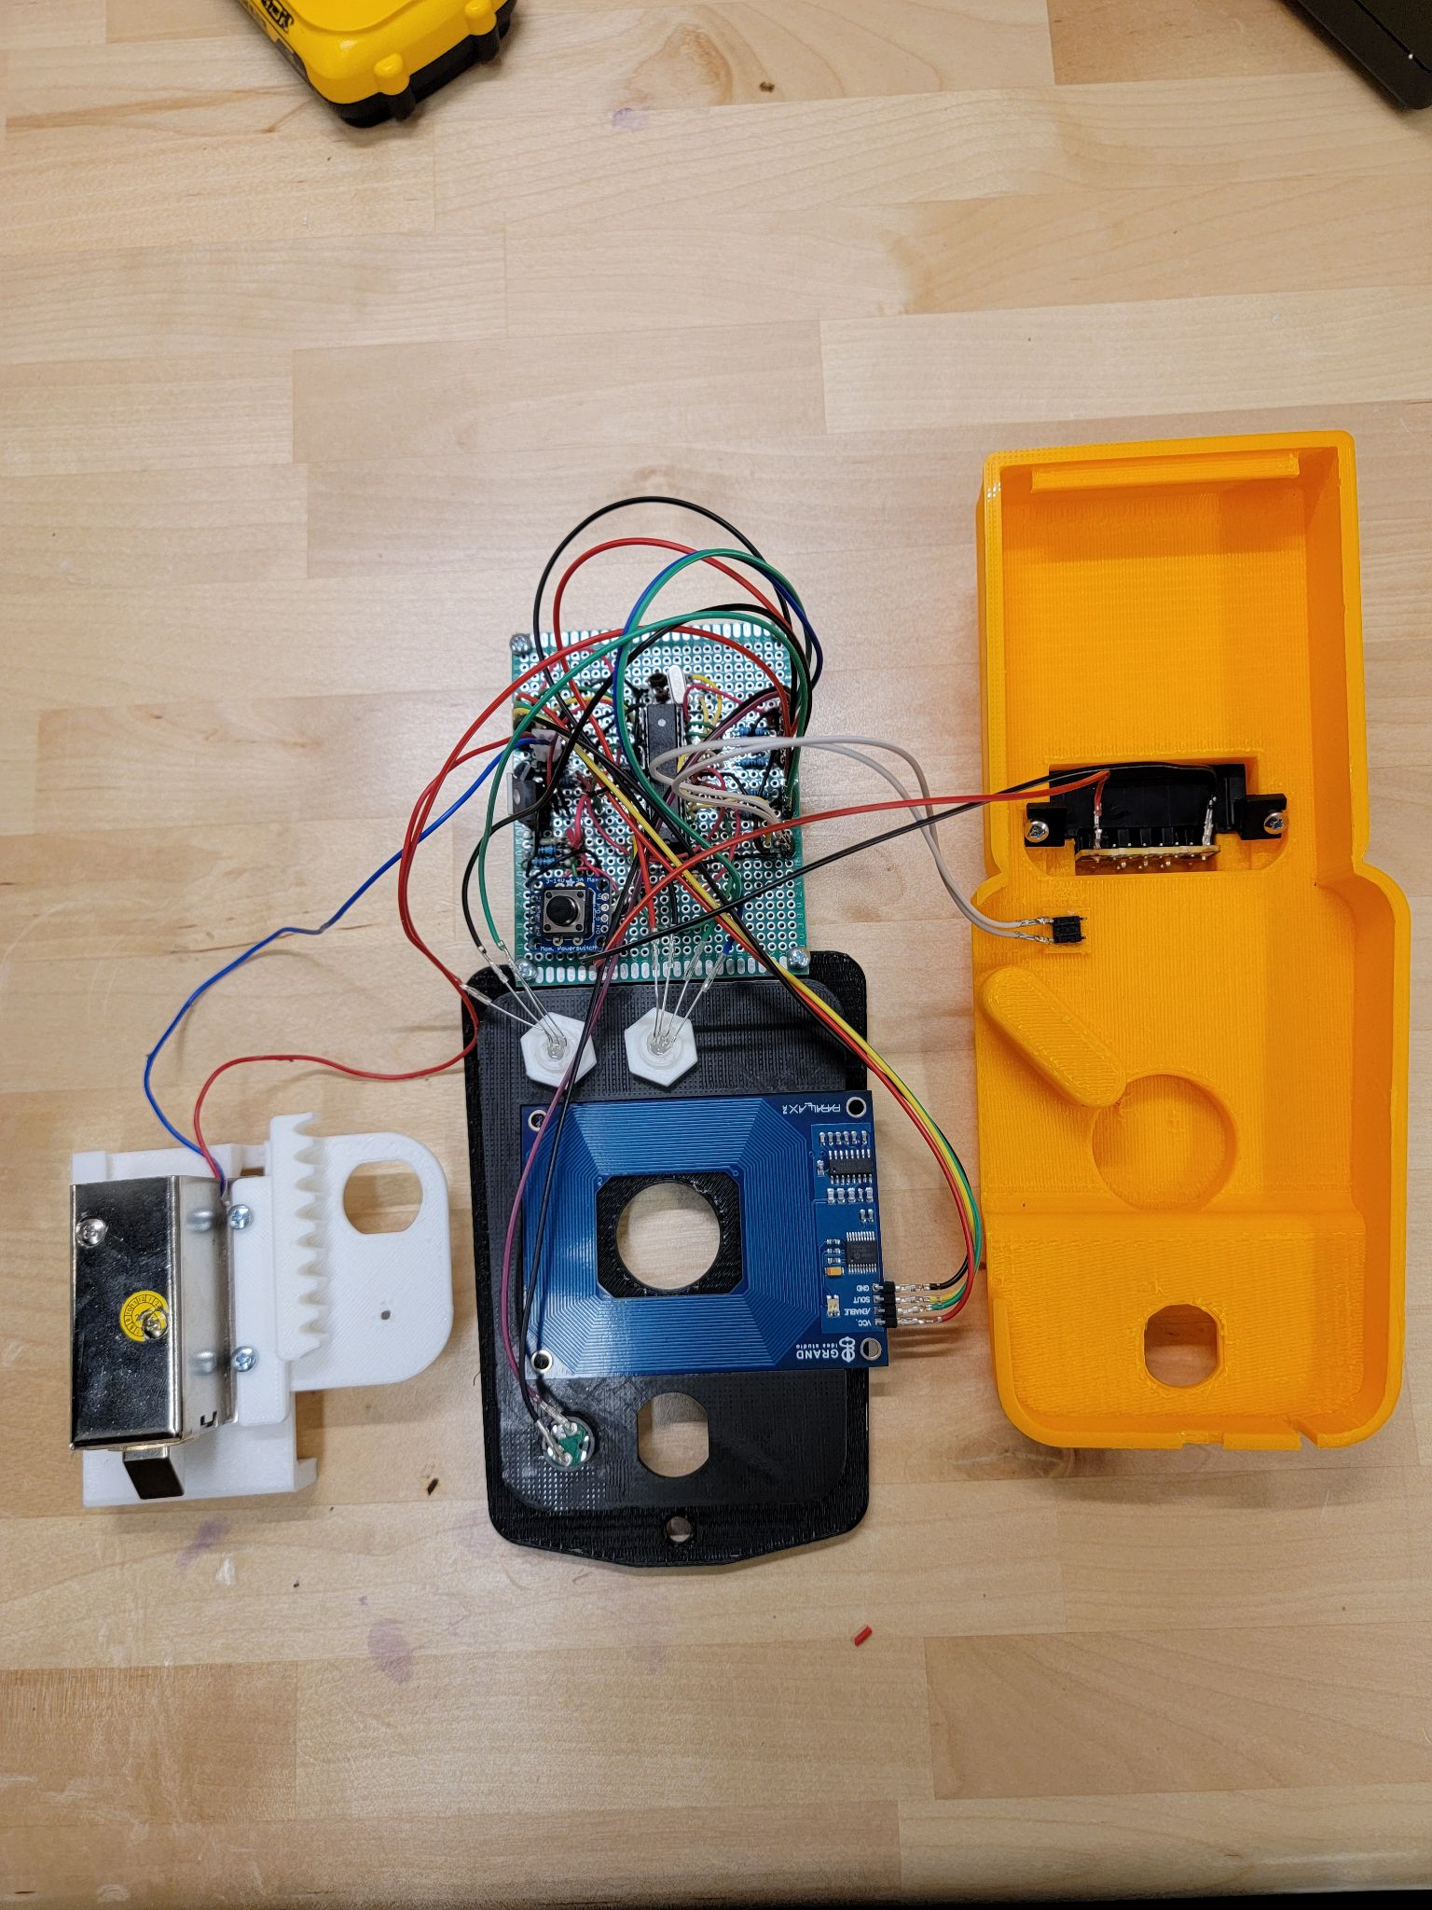

This picture shows the schematic of the whole circuit along with its components.

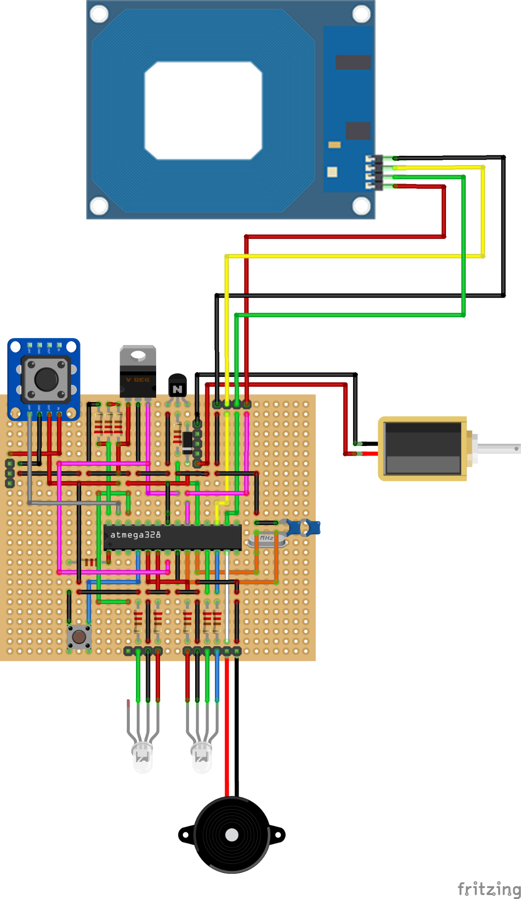

1. Next thing is assembling the mechanical override. This feature is only to be used in case of emergency such as the battery being dead or accidental being locked without a fully functional circuit. To start off, you take the gear rack and screw it to the top of the solenoid, as shown on the left picture below, using the M3-0.5 x 6 mm screws. Then you tighten the rack in its place by using M3-0.5 nuts shown in the picture on the right. 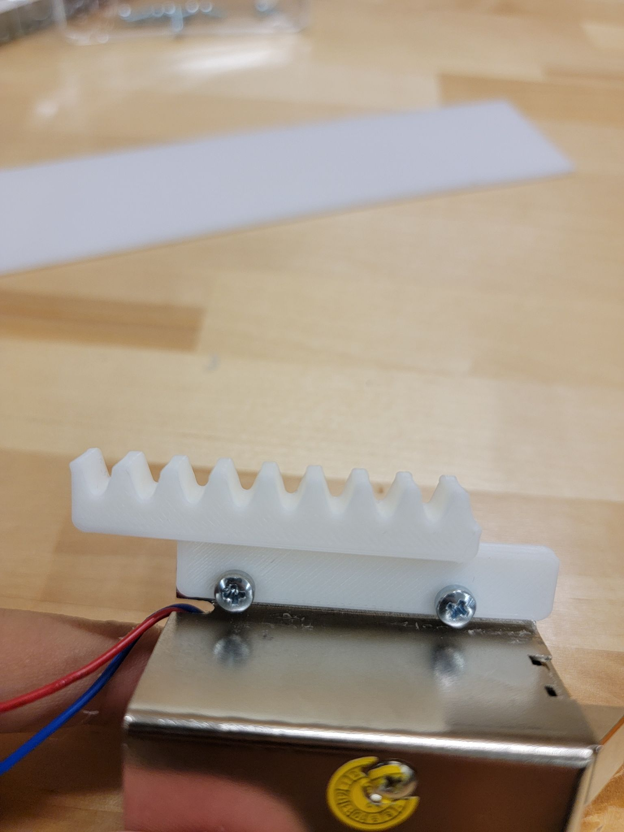

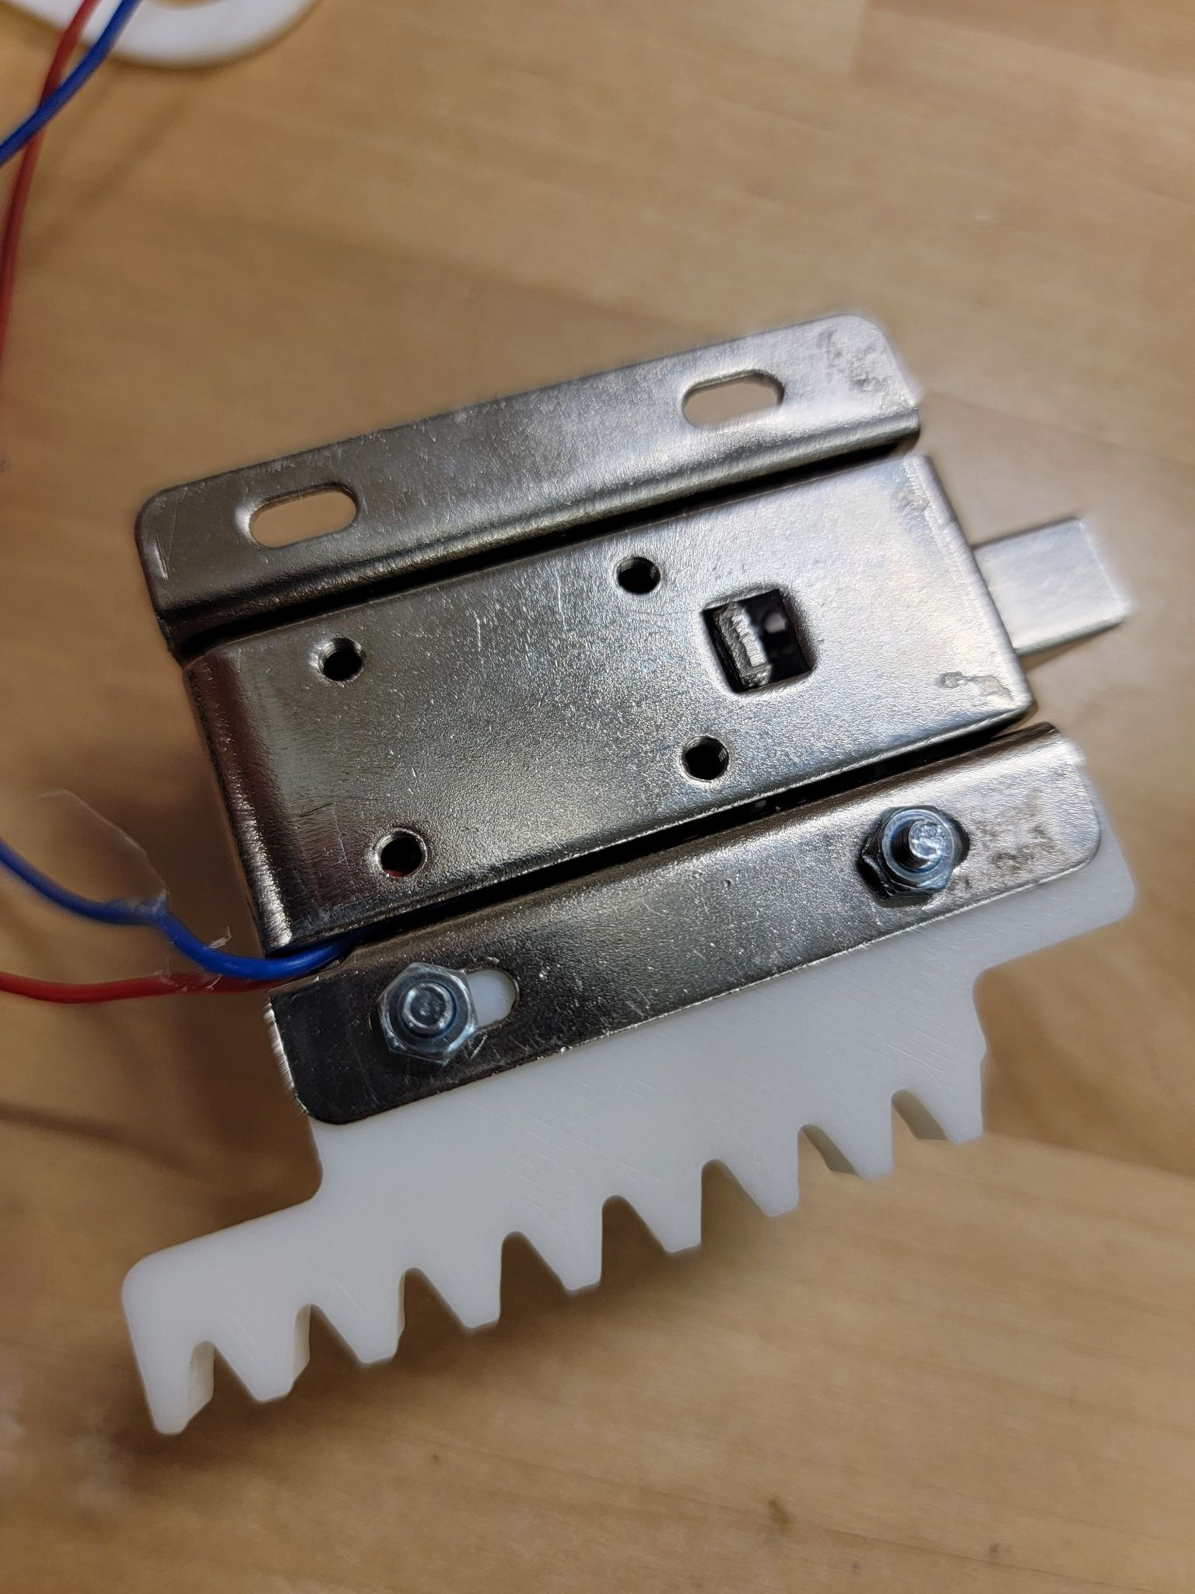

1. Take the solenoid and slide it into the bracket as shown on the left picture. You should now have something that looks like the picture on the right from the back with the screws and nuts visible.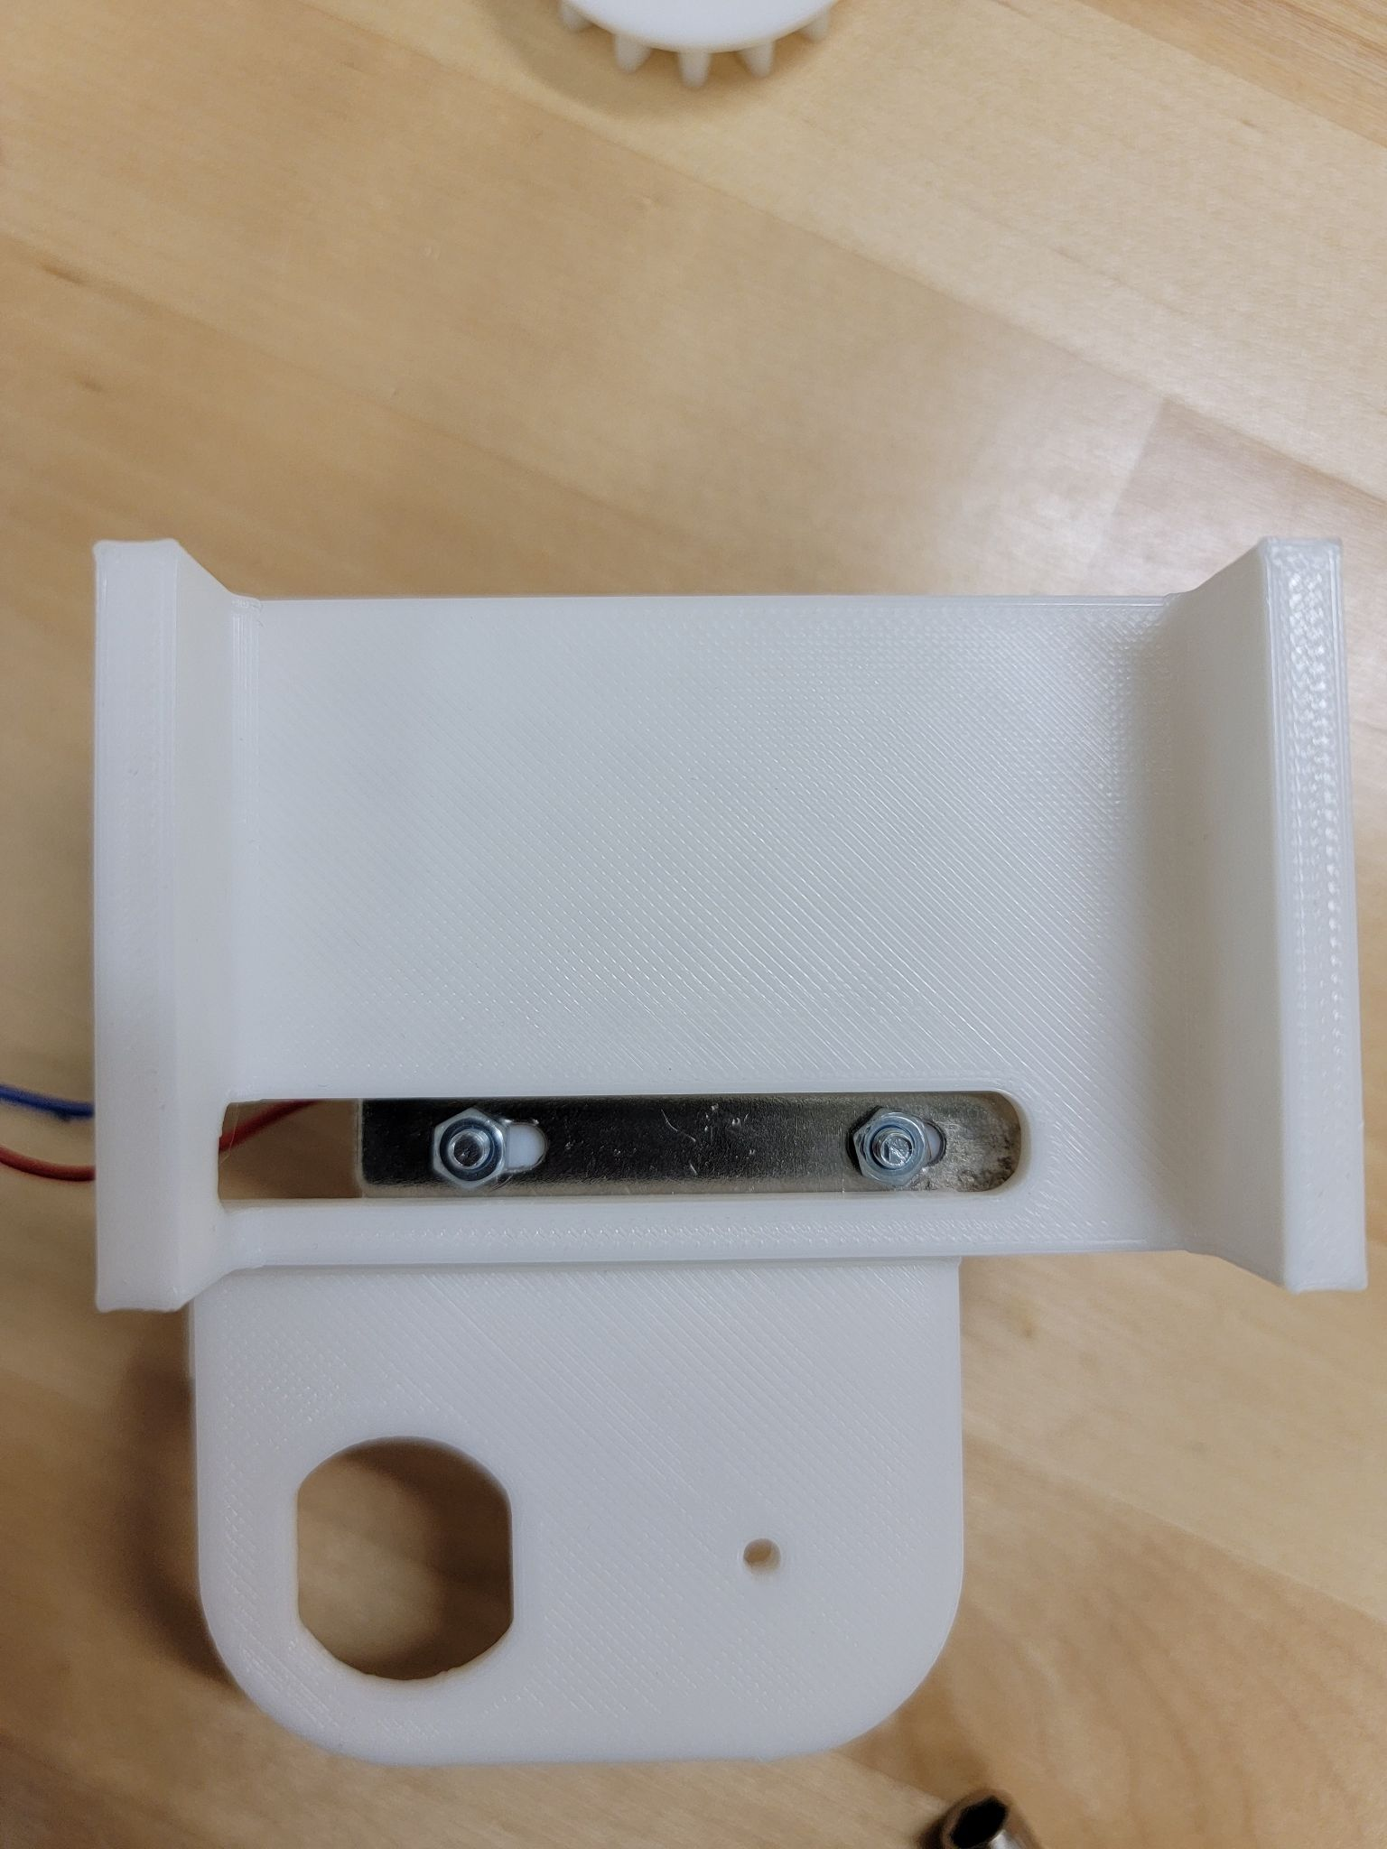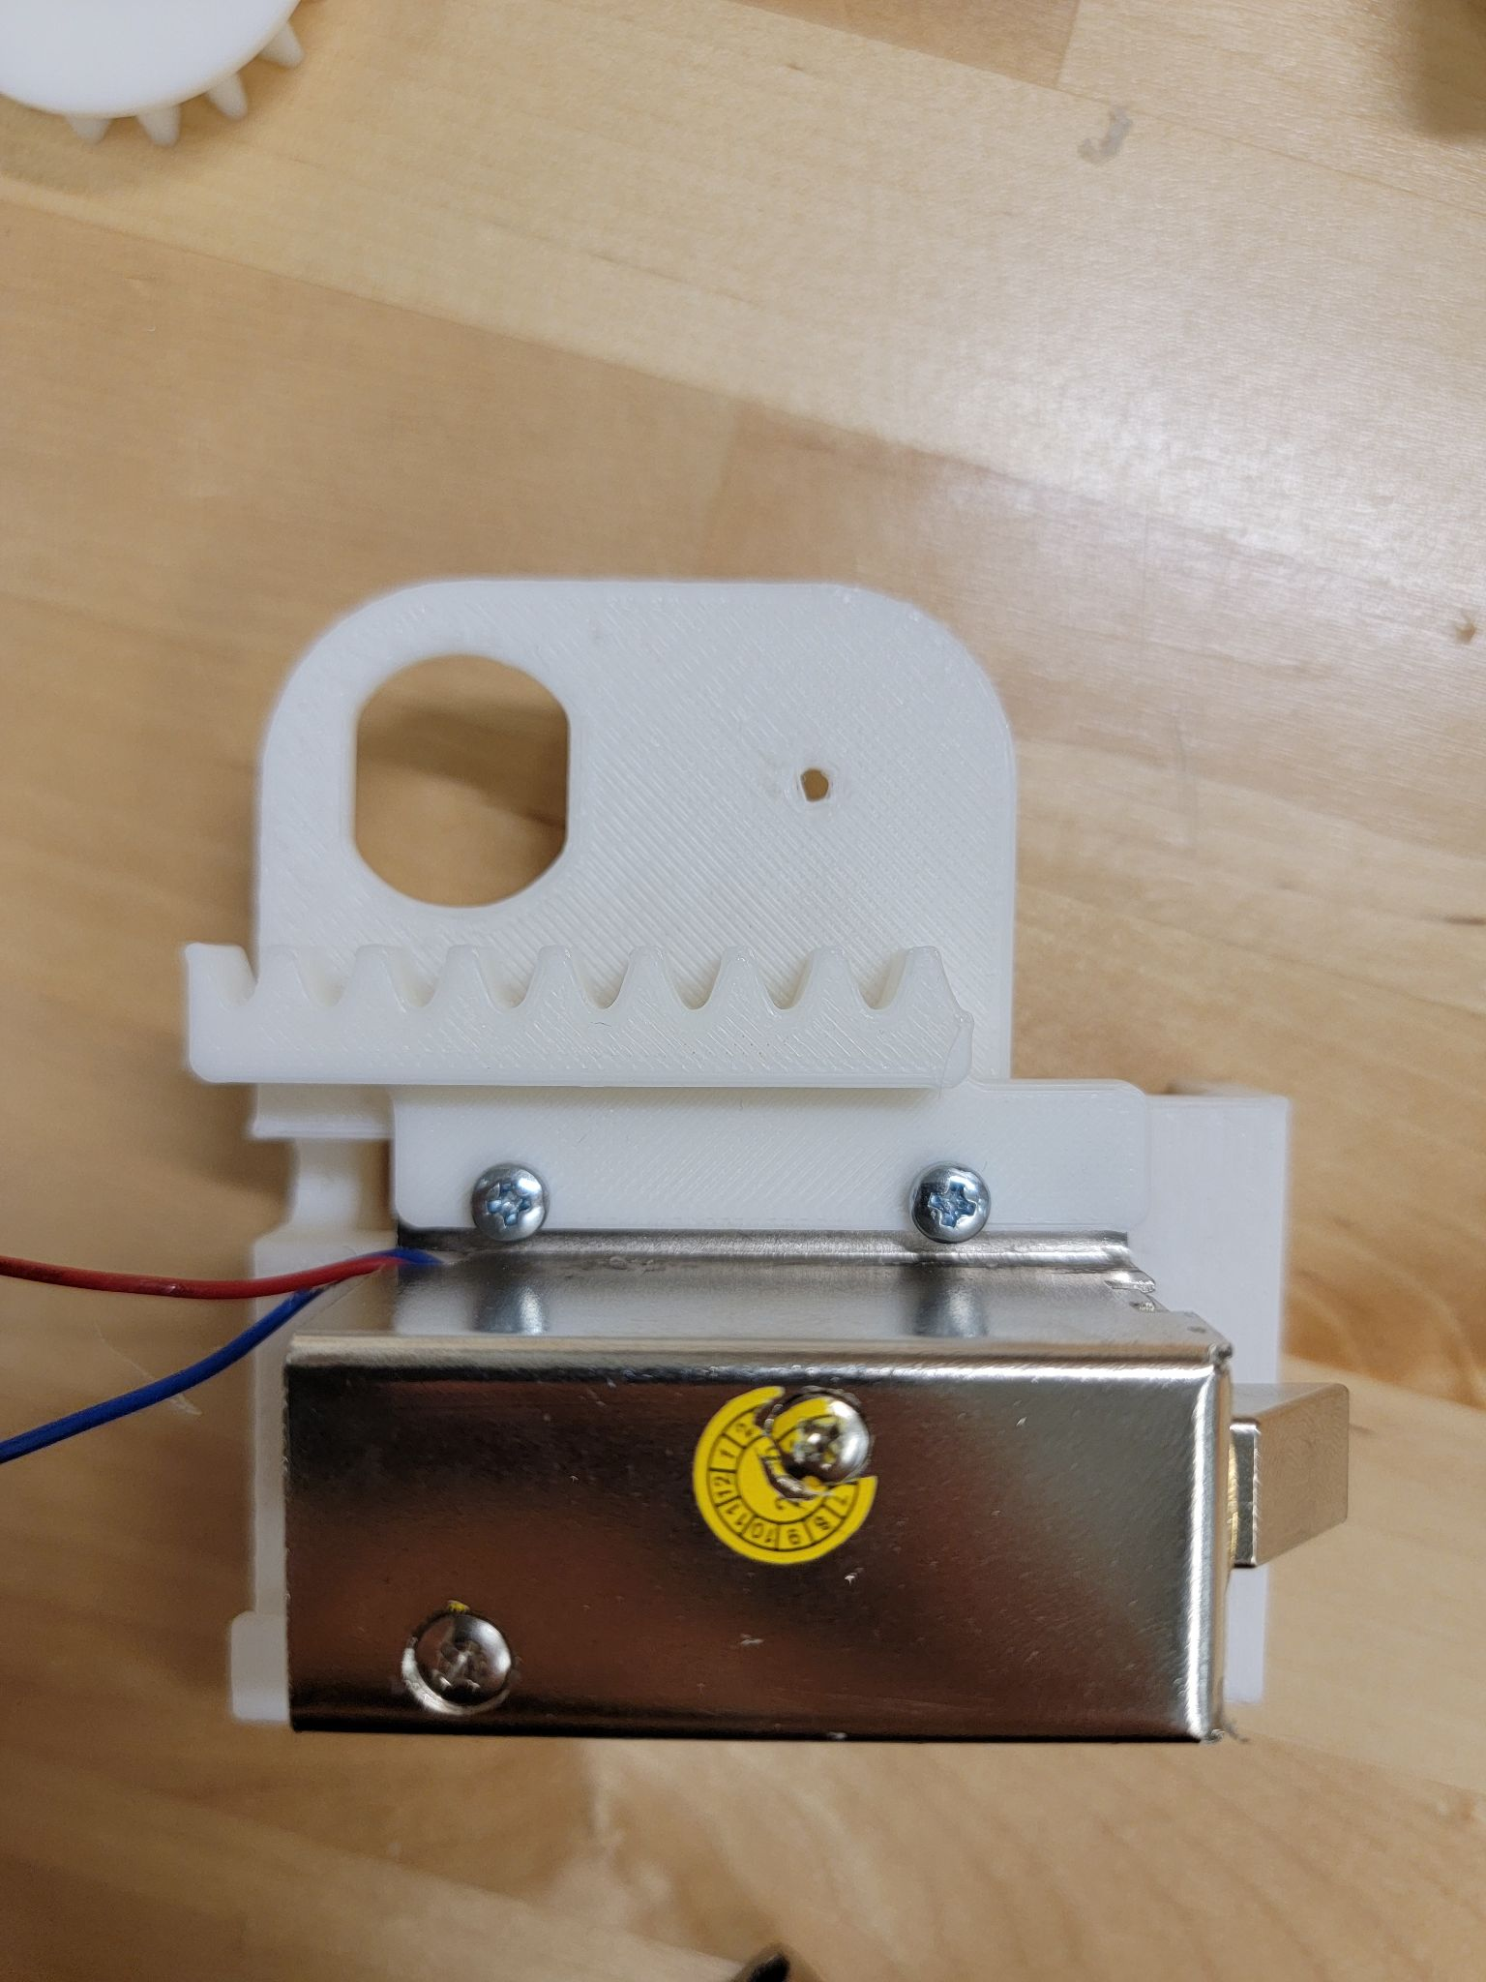
2. The next step is putting all the parts onto the hole in the locker. **Note: For Alden High School locker, you will first need to remove the lock component that is in the way. Since we did not have a model for the locker at Alden, we are unsure on how to do that. But, you will need to do that first before implementing this step. The Depew High School locker can just start the step from here.** Next, you will need to disconnect the battery mount, solenoid, and the reset button wires from the board. You will then have to dismount the RFID module (no need to disconnect any wires) from the middle of the locker insert and carefully insert the black locker insert into the locker. Once you do that, you can mount the RFID back onto its place. It should look something like the picture shown on the right. Everything else in the locker looks the same for both high schools. Therefore, you can follow the rest of the assembly guide.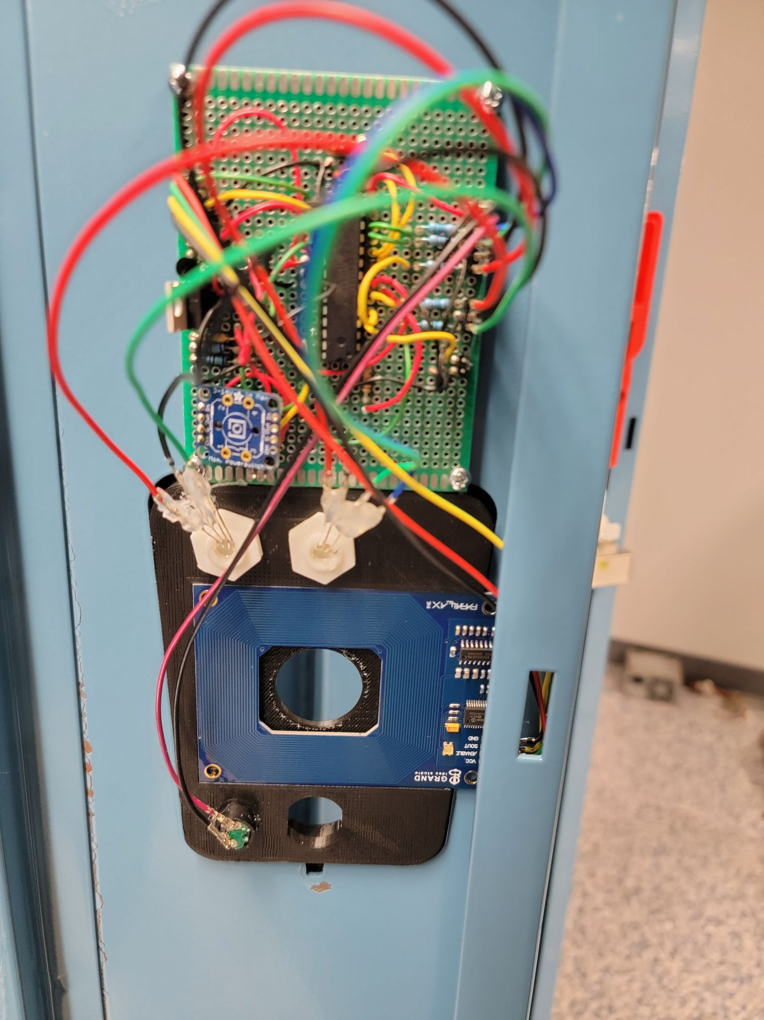
3. Once you do that, you can screw the locker insert in place using the original screw and nut from the unmodified locker. Make sure you tighten the screw shown on the left so that it is secure. It is very important to do that because the whole design is supported by that screw and nut. Once you do that, it should look like that from the front.

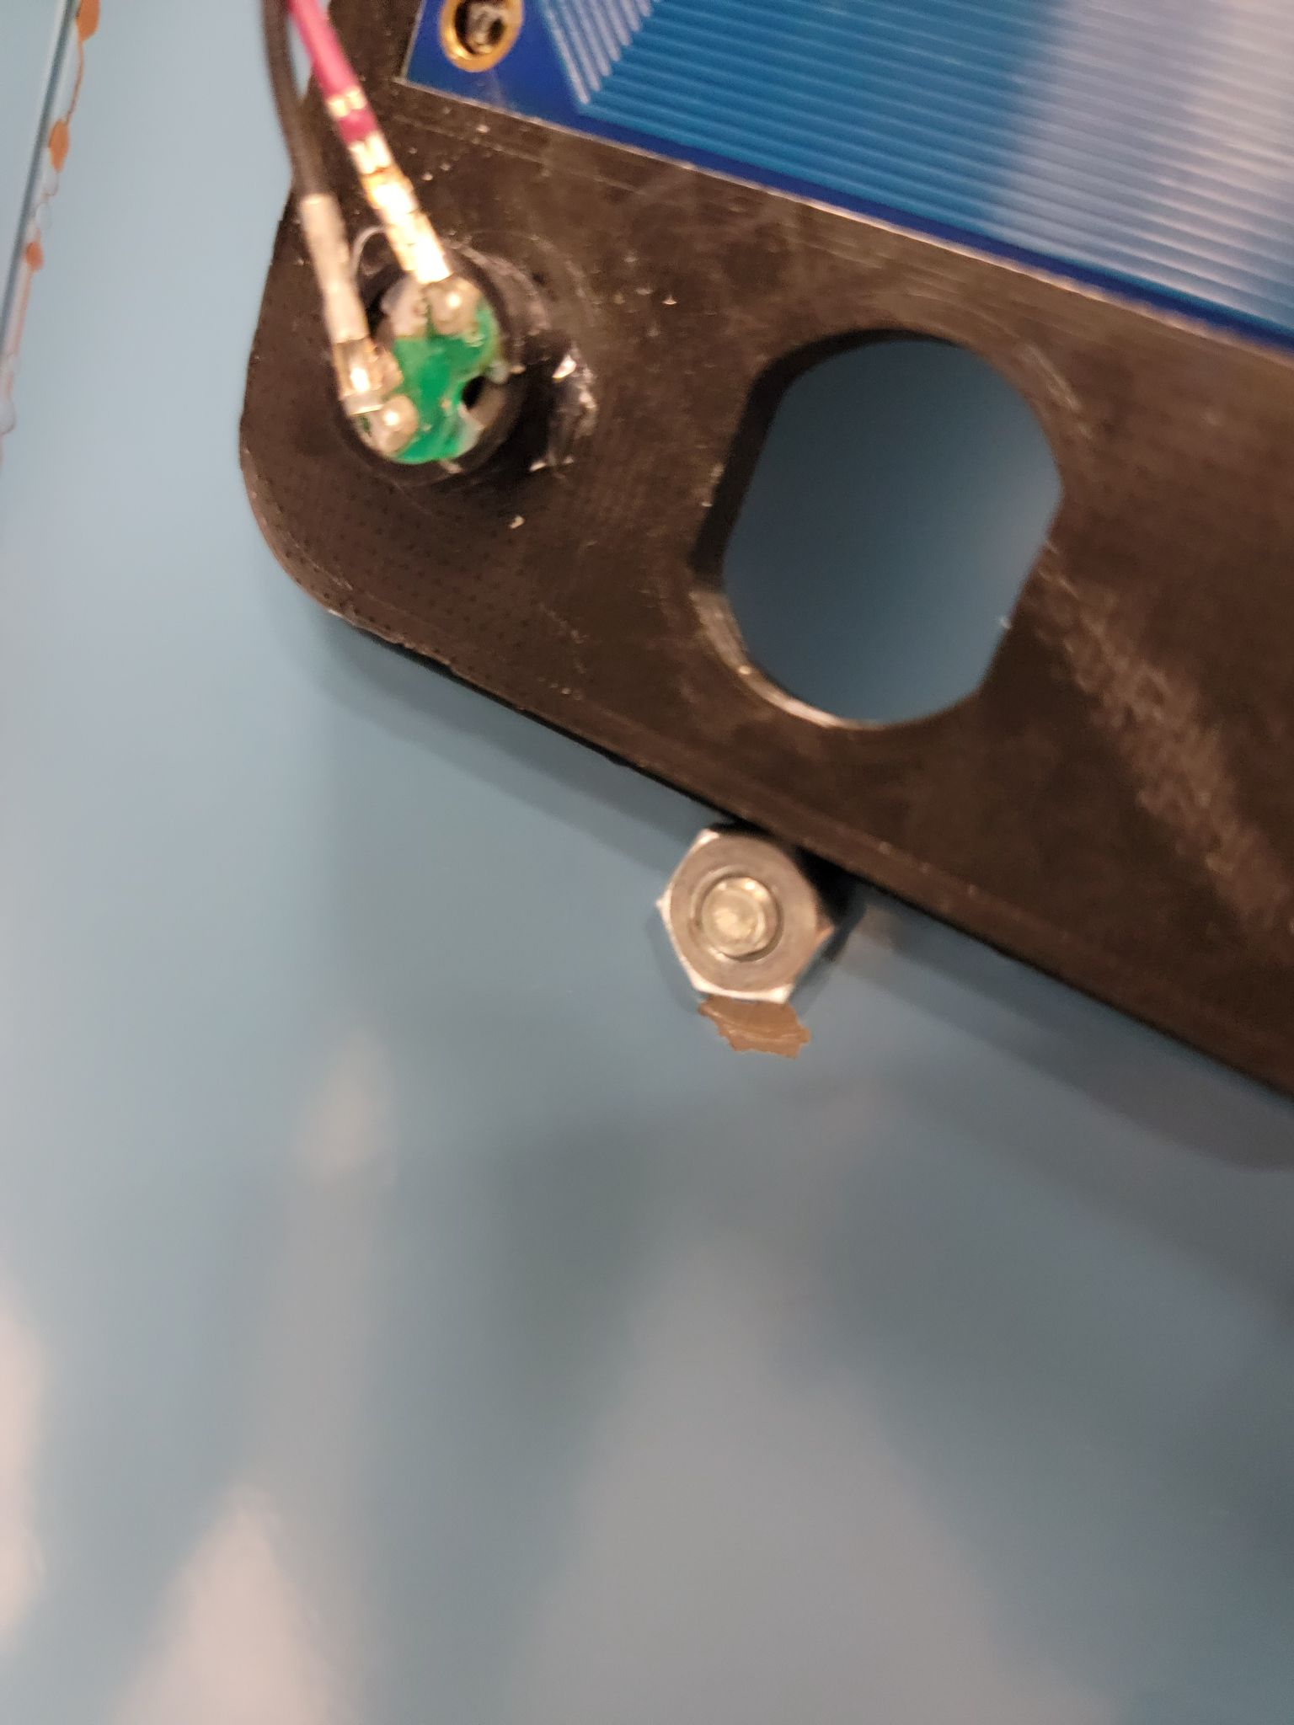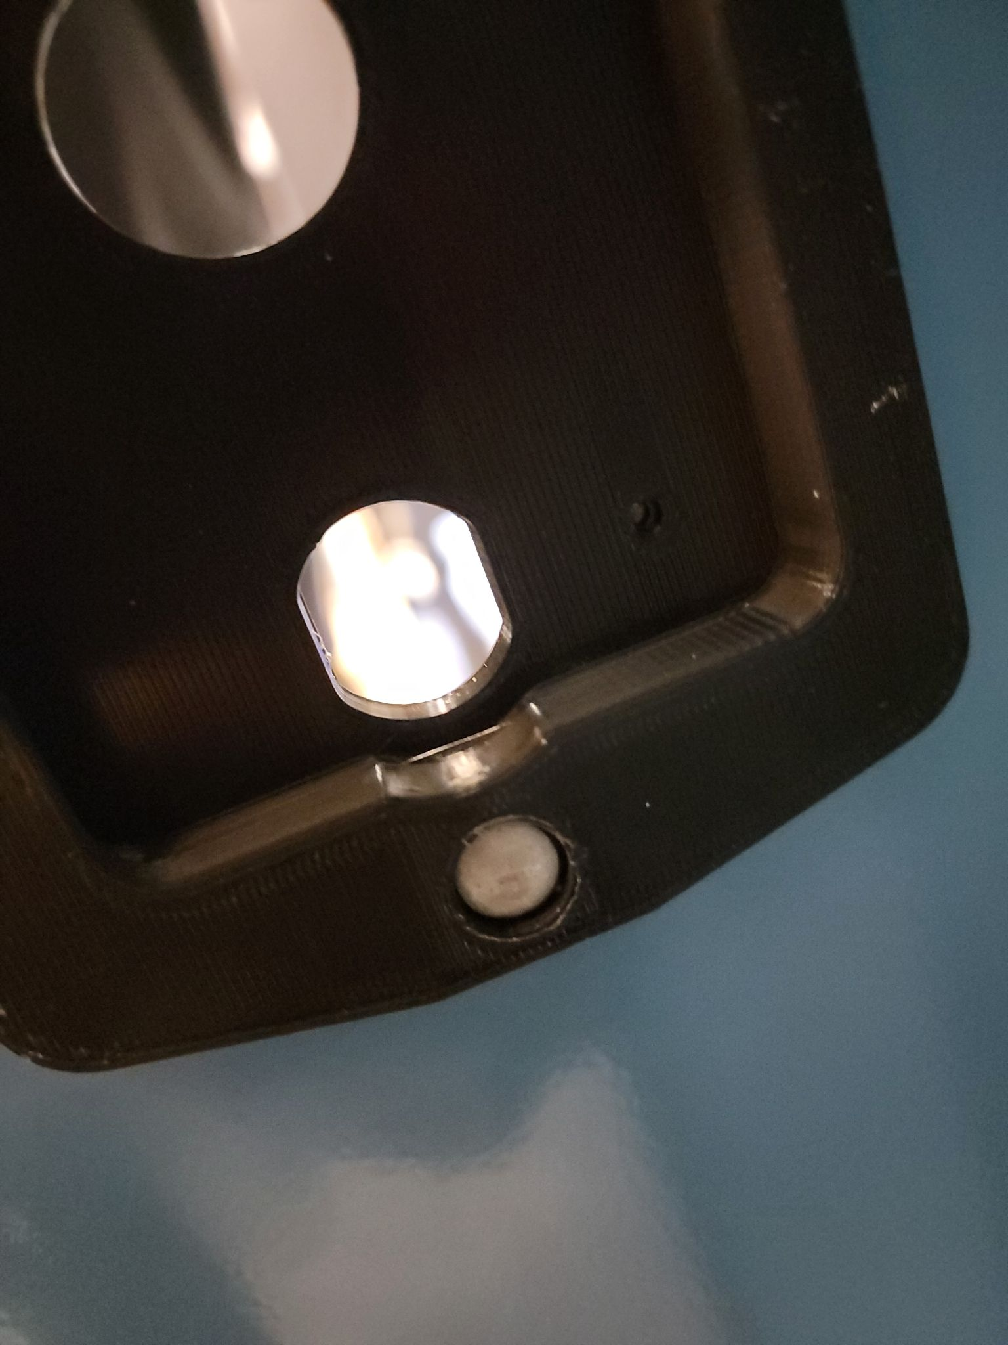

1. The next step is to add the power button. To do that, take two jumper cables and hang them around the two holes of the button. Then use pliers to twist them and secure them in place as shown in the picture below. This is an important step because that is the main button responsible for turning on the circuit. 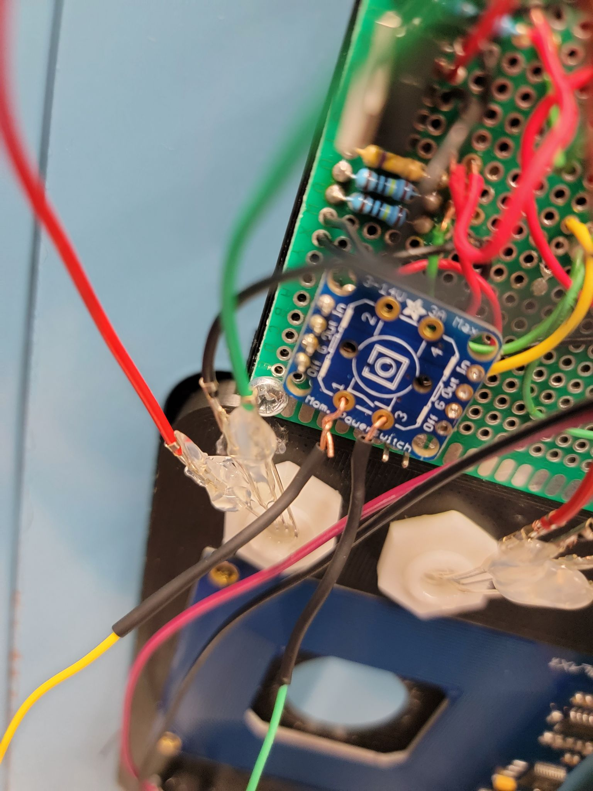
2. Add the push button from the front of the locker insert as shown in the picture on the left below. Then put the nut on it from the opposite end so that the button is securely attached to the locker insert and is not moving. A picture of that is shown below on the right.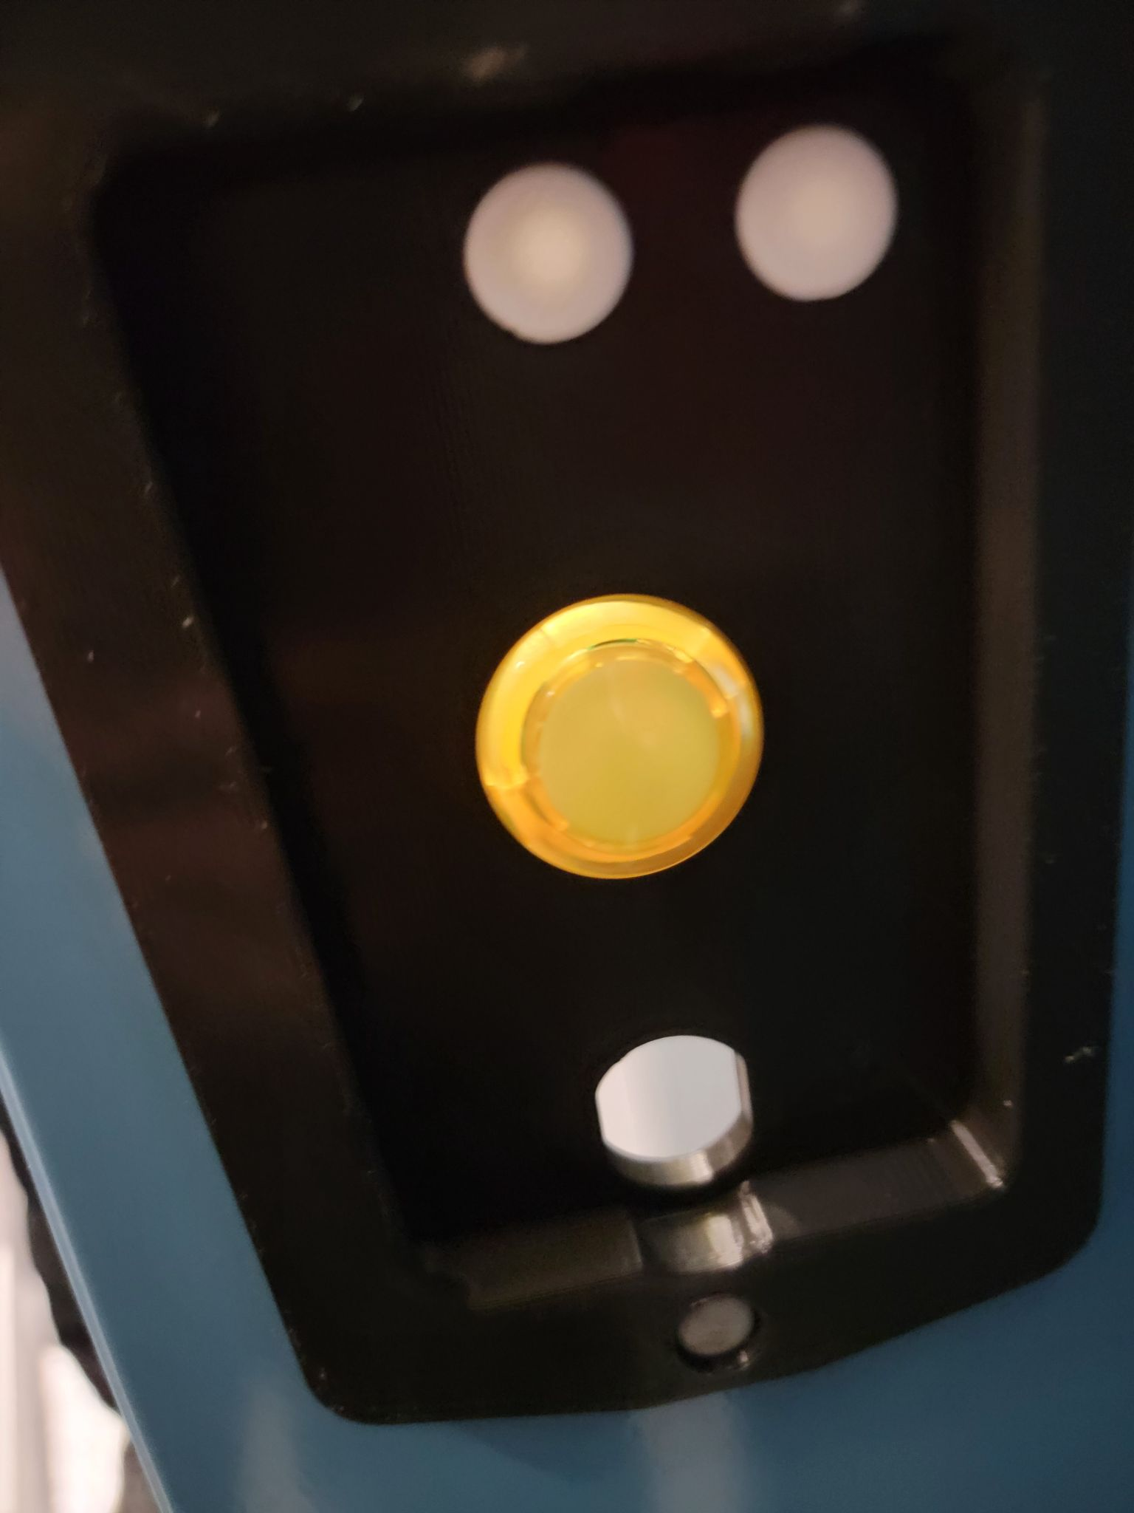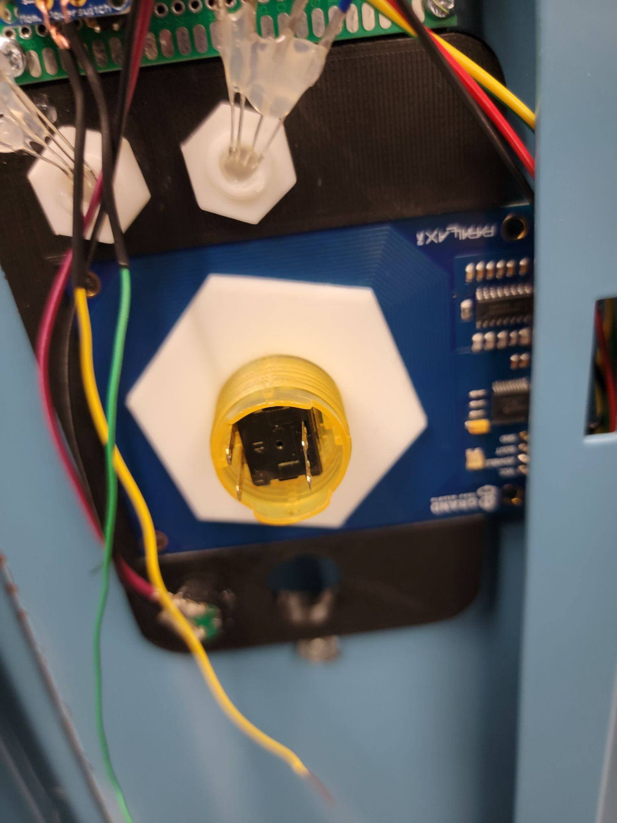
3. Take the two cables (from step 21) and attach them to the two small ends of the button. Use pliers to twist them around the pin and secure them in place. Use the picture below as reference.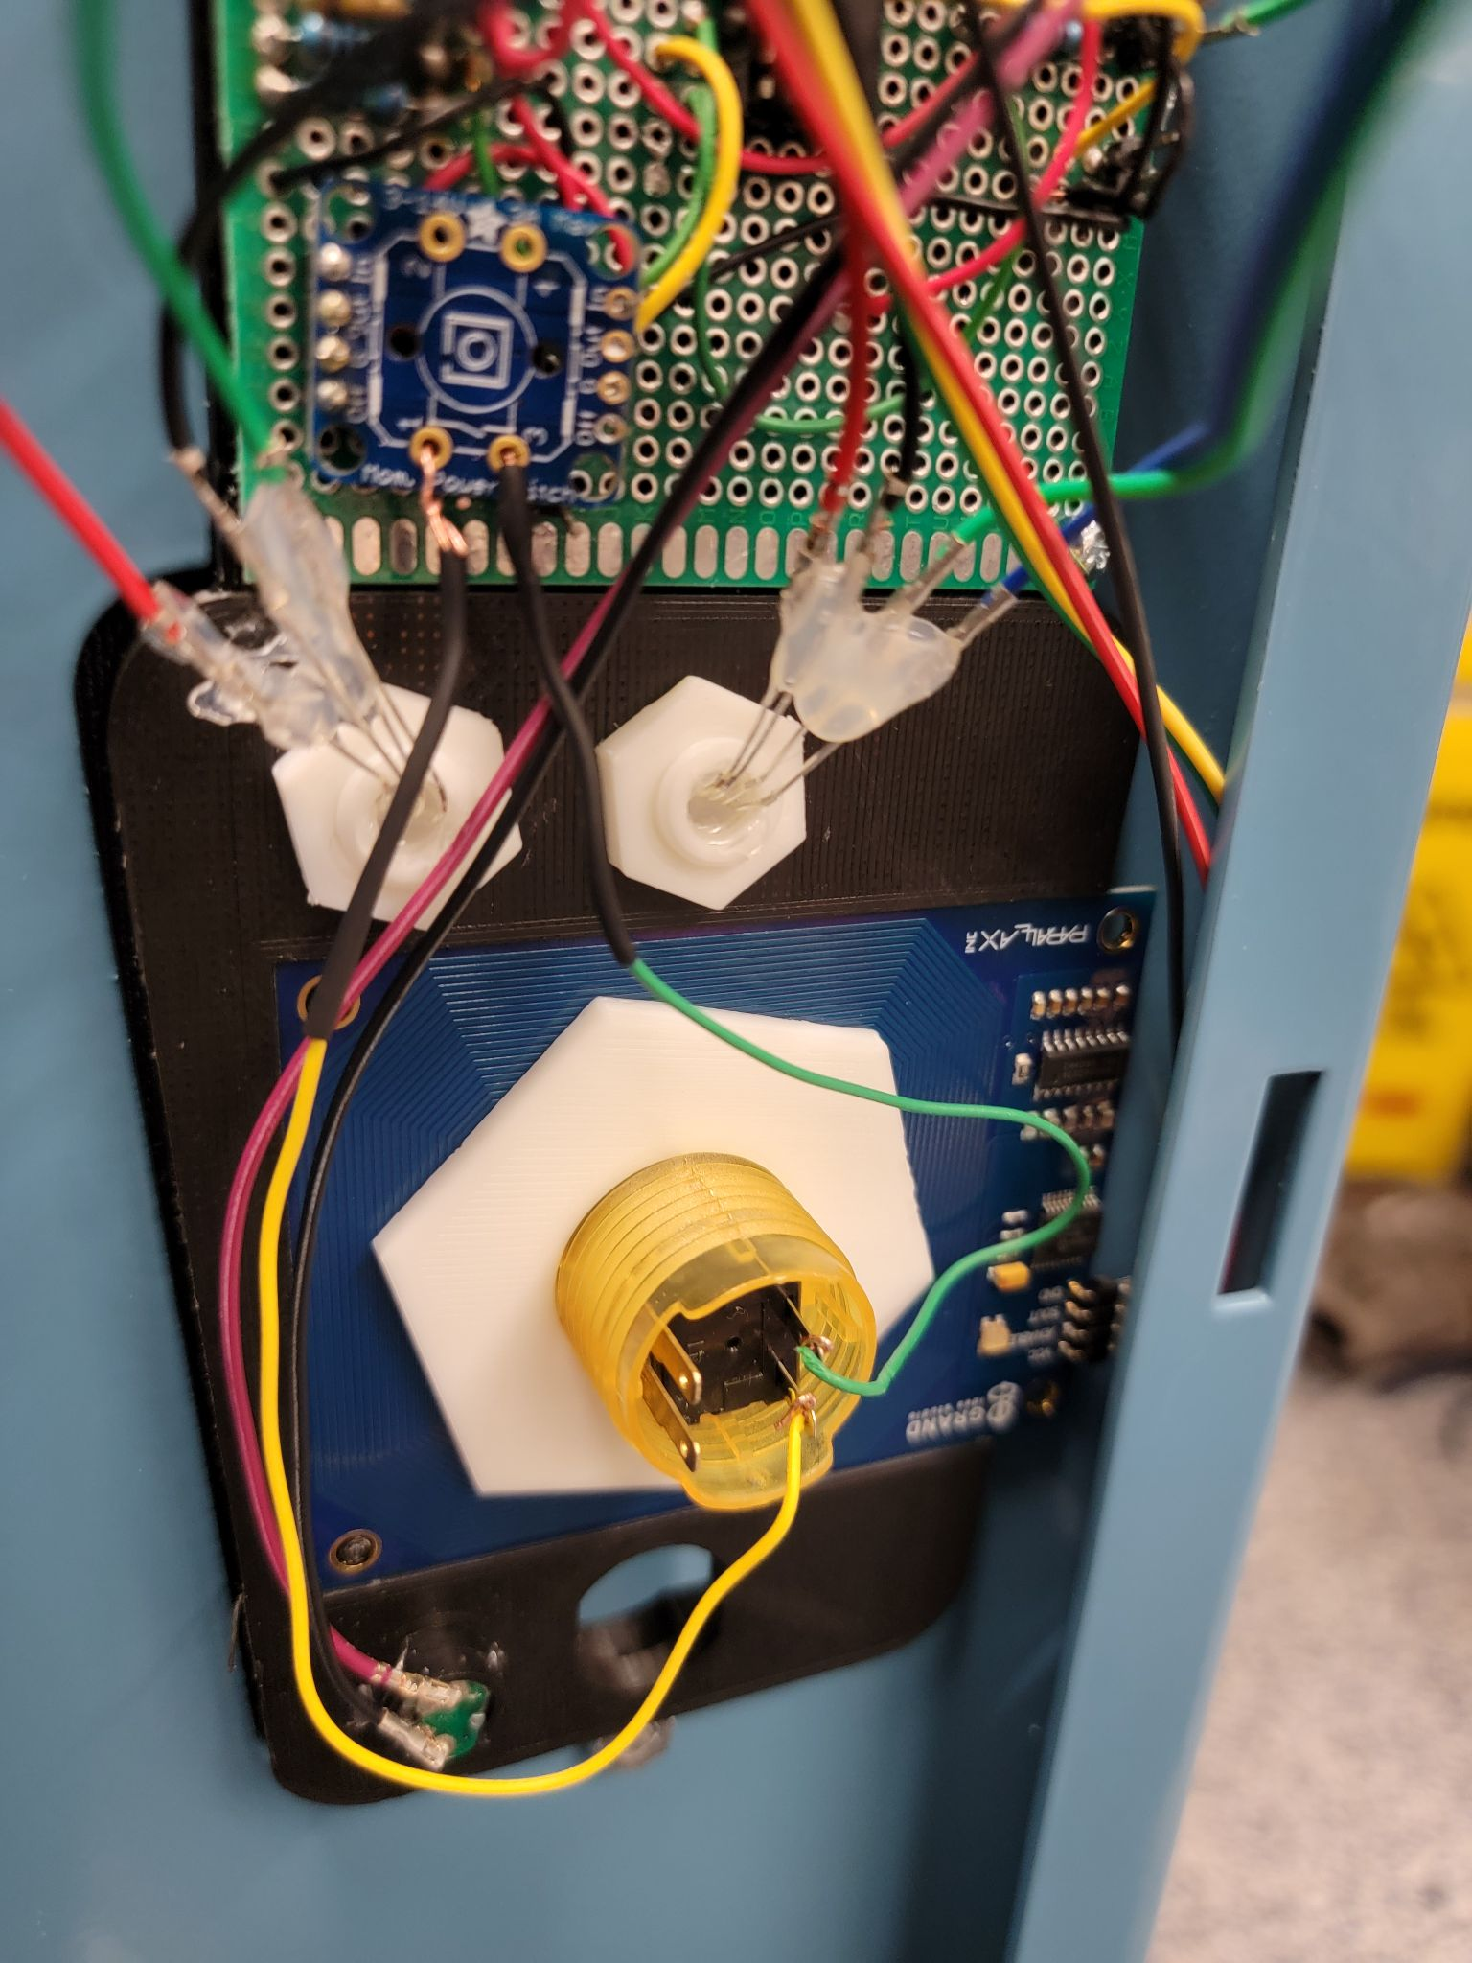
4. Attach all the peripherals now include the solenoid, reset button, and the power mount. See steps 10, 11, and 15 for reference if needed. At this point, you should have something that is shown in the picture below. You are now ready to close the case.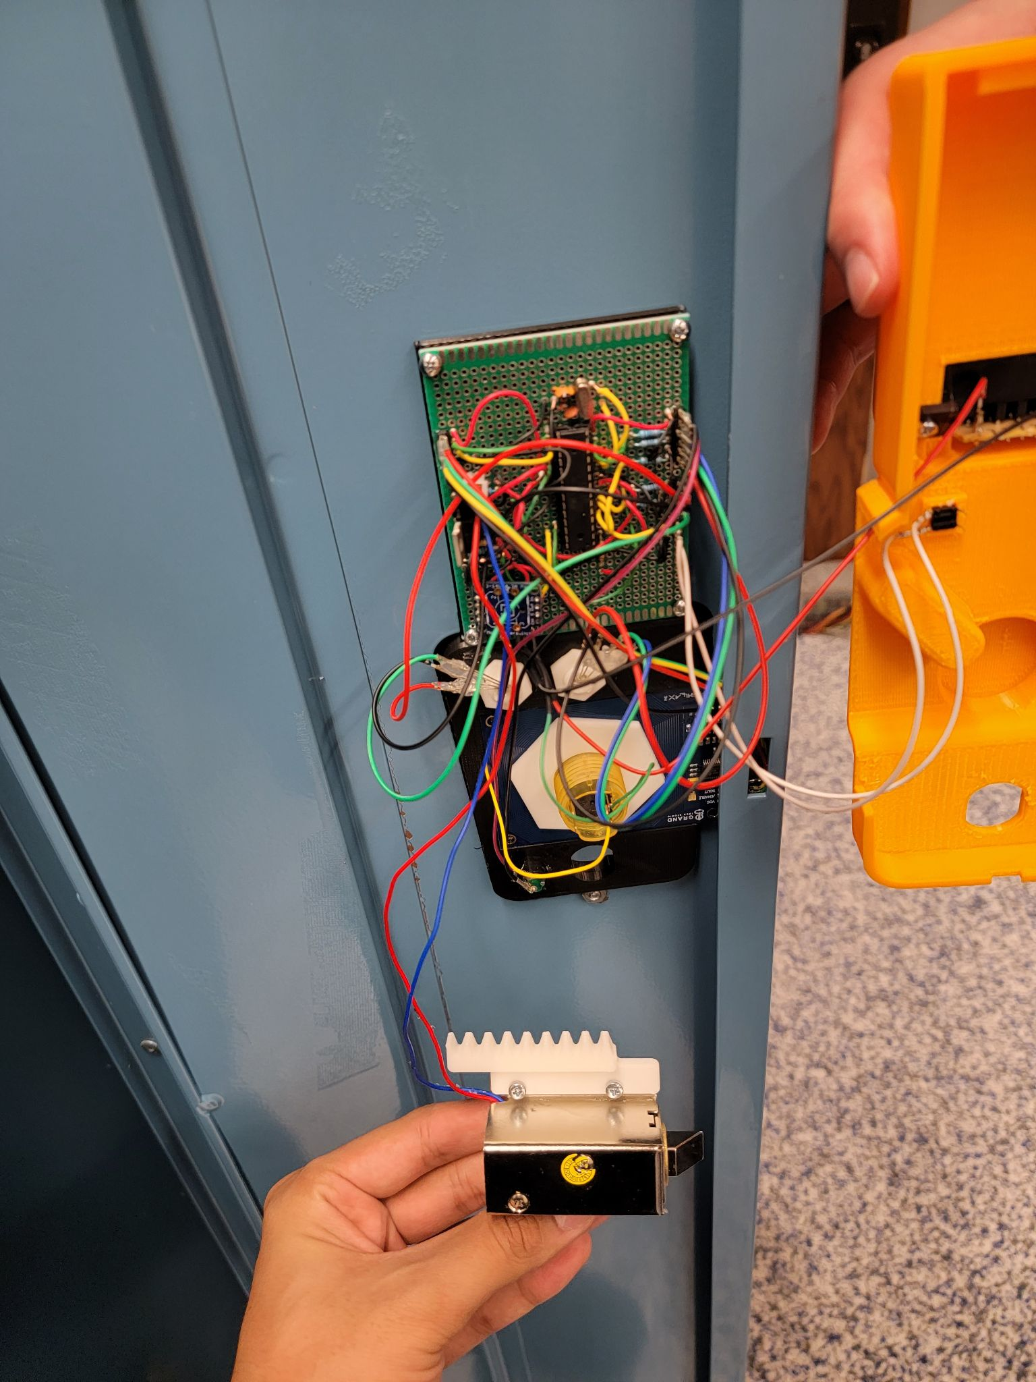
5. Before you proceed with this step, ensure all the connections are tight and in place. There is a notch behind the locker insert case as you can see in the picture on the left below. This notch goes in the space between the circuit board and the insert (shown in the picture right below) to firmly close the insert. There is a small hole on the bottom of the locker insert case. This is for the wires of the solenoid. Check the picture on the bottom of this page if you are unclear.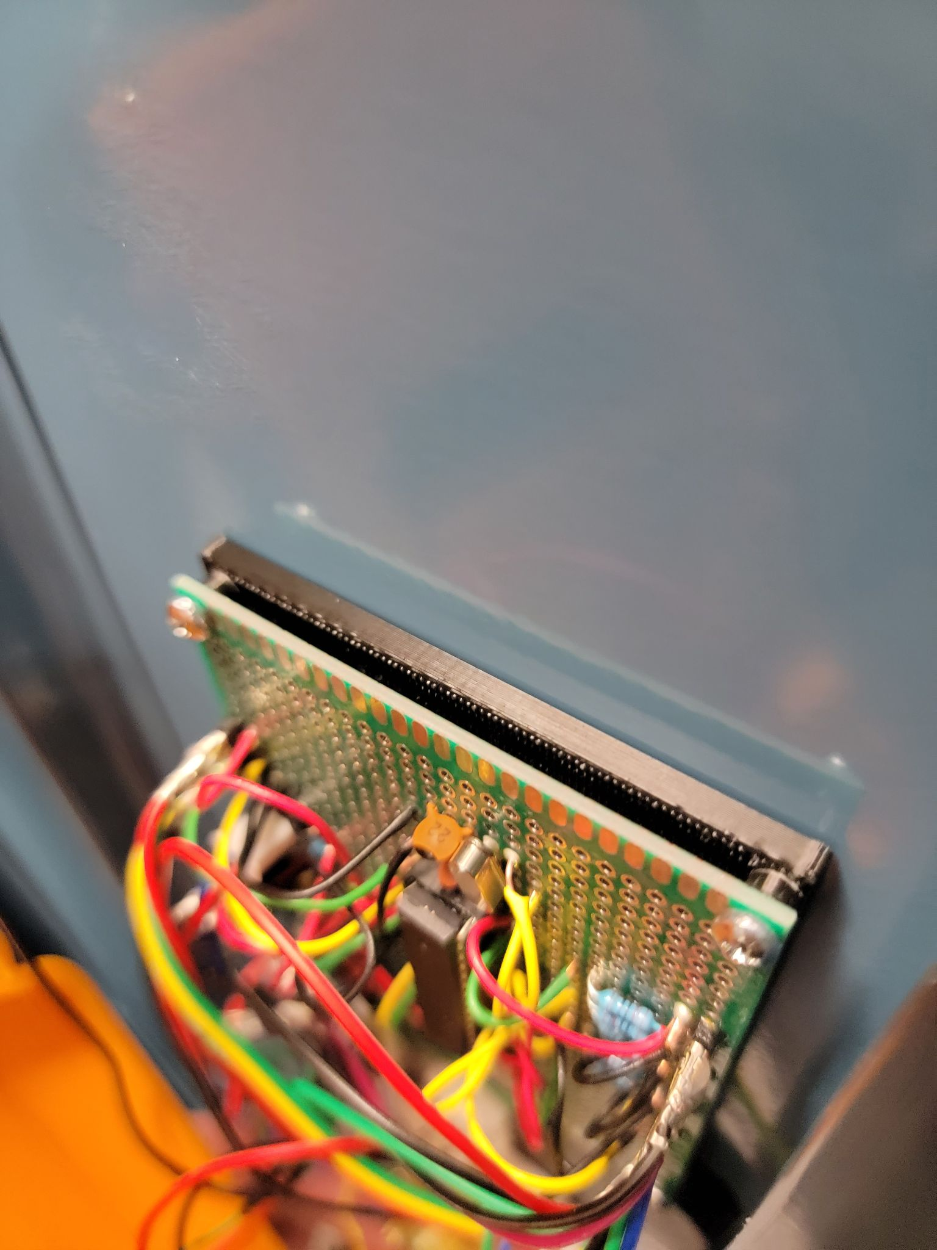

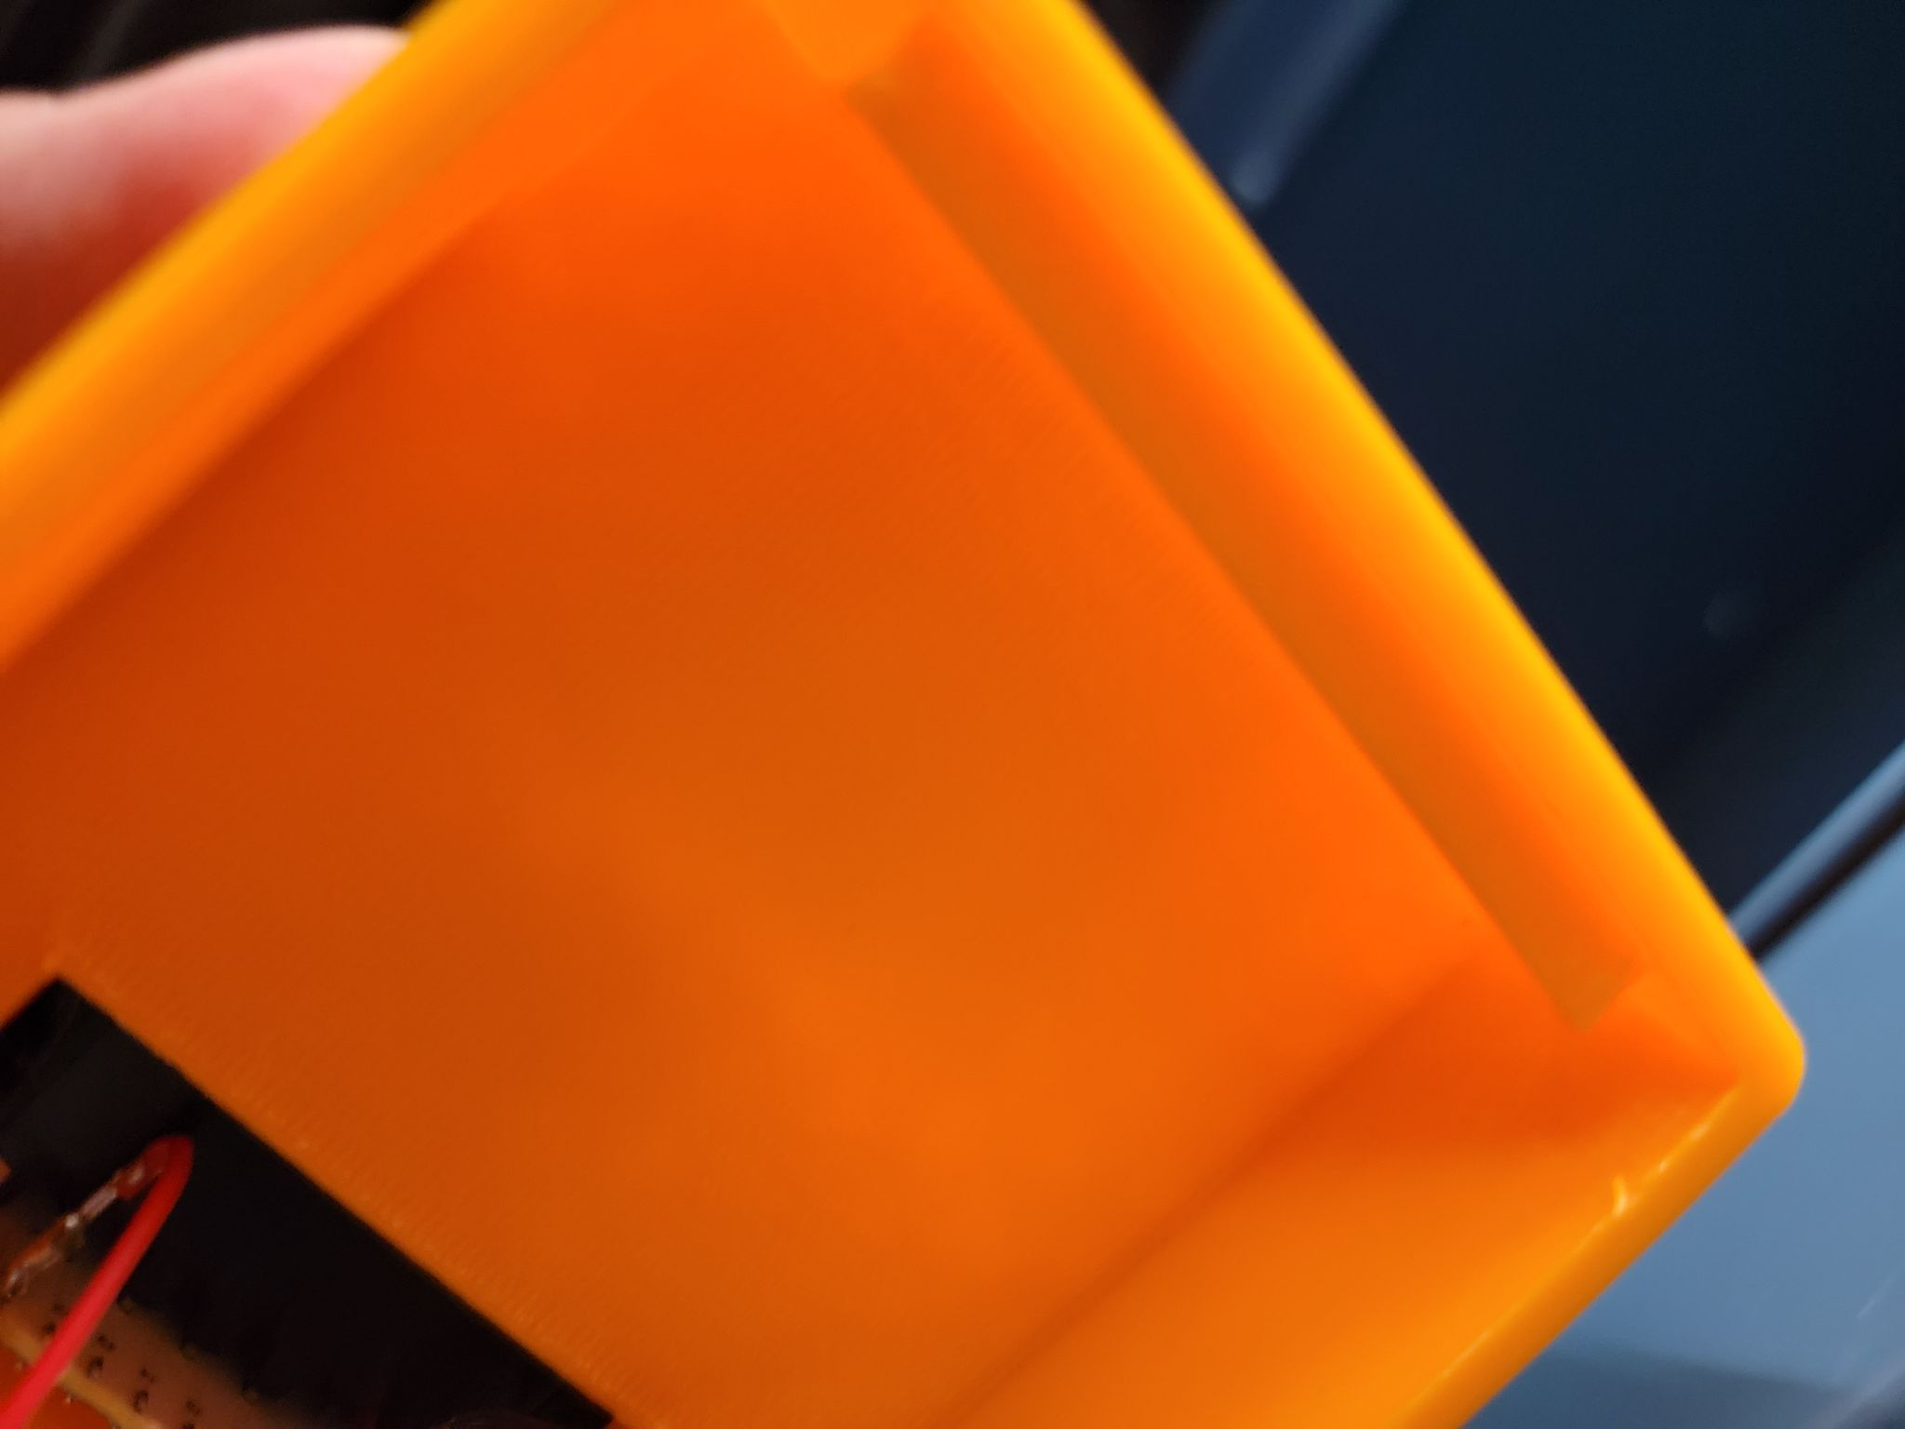

1. Once you close the insert case, insert the cabinet lock from the outside so that it looks something shown below. At this point, the case should be intact and in place.

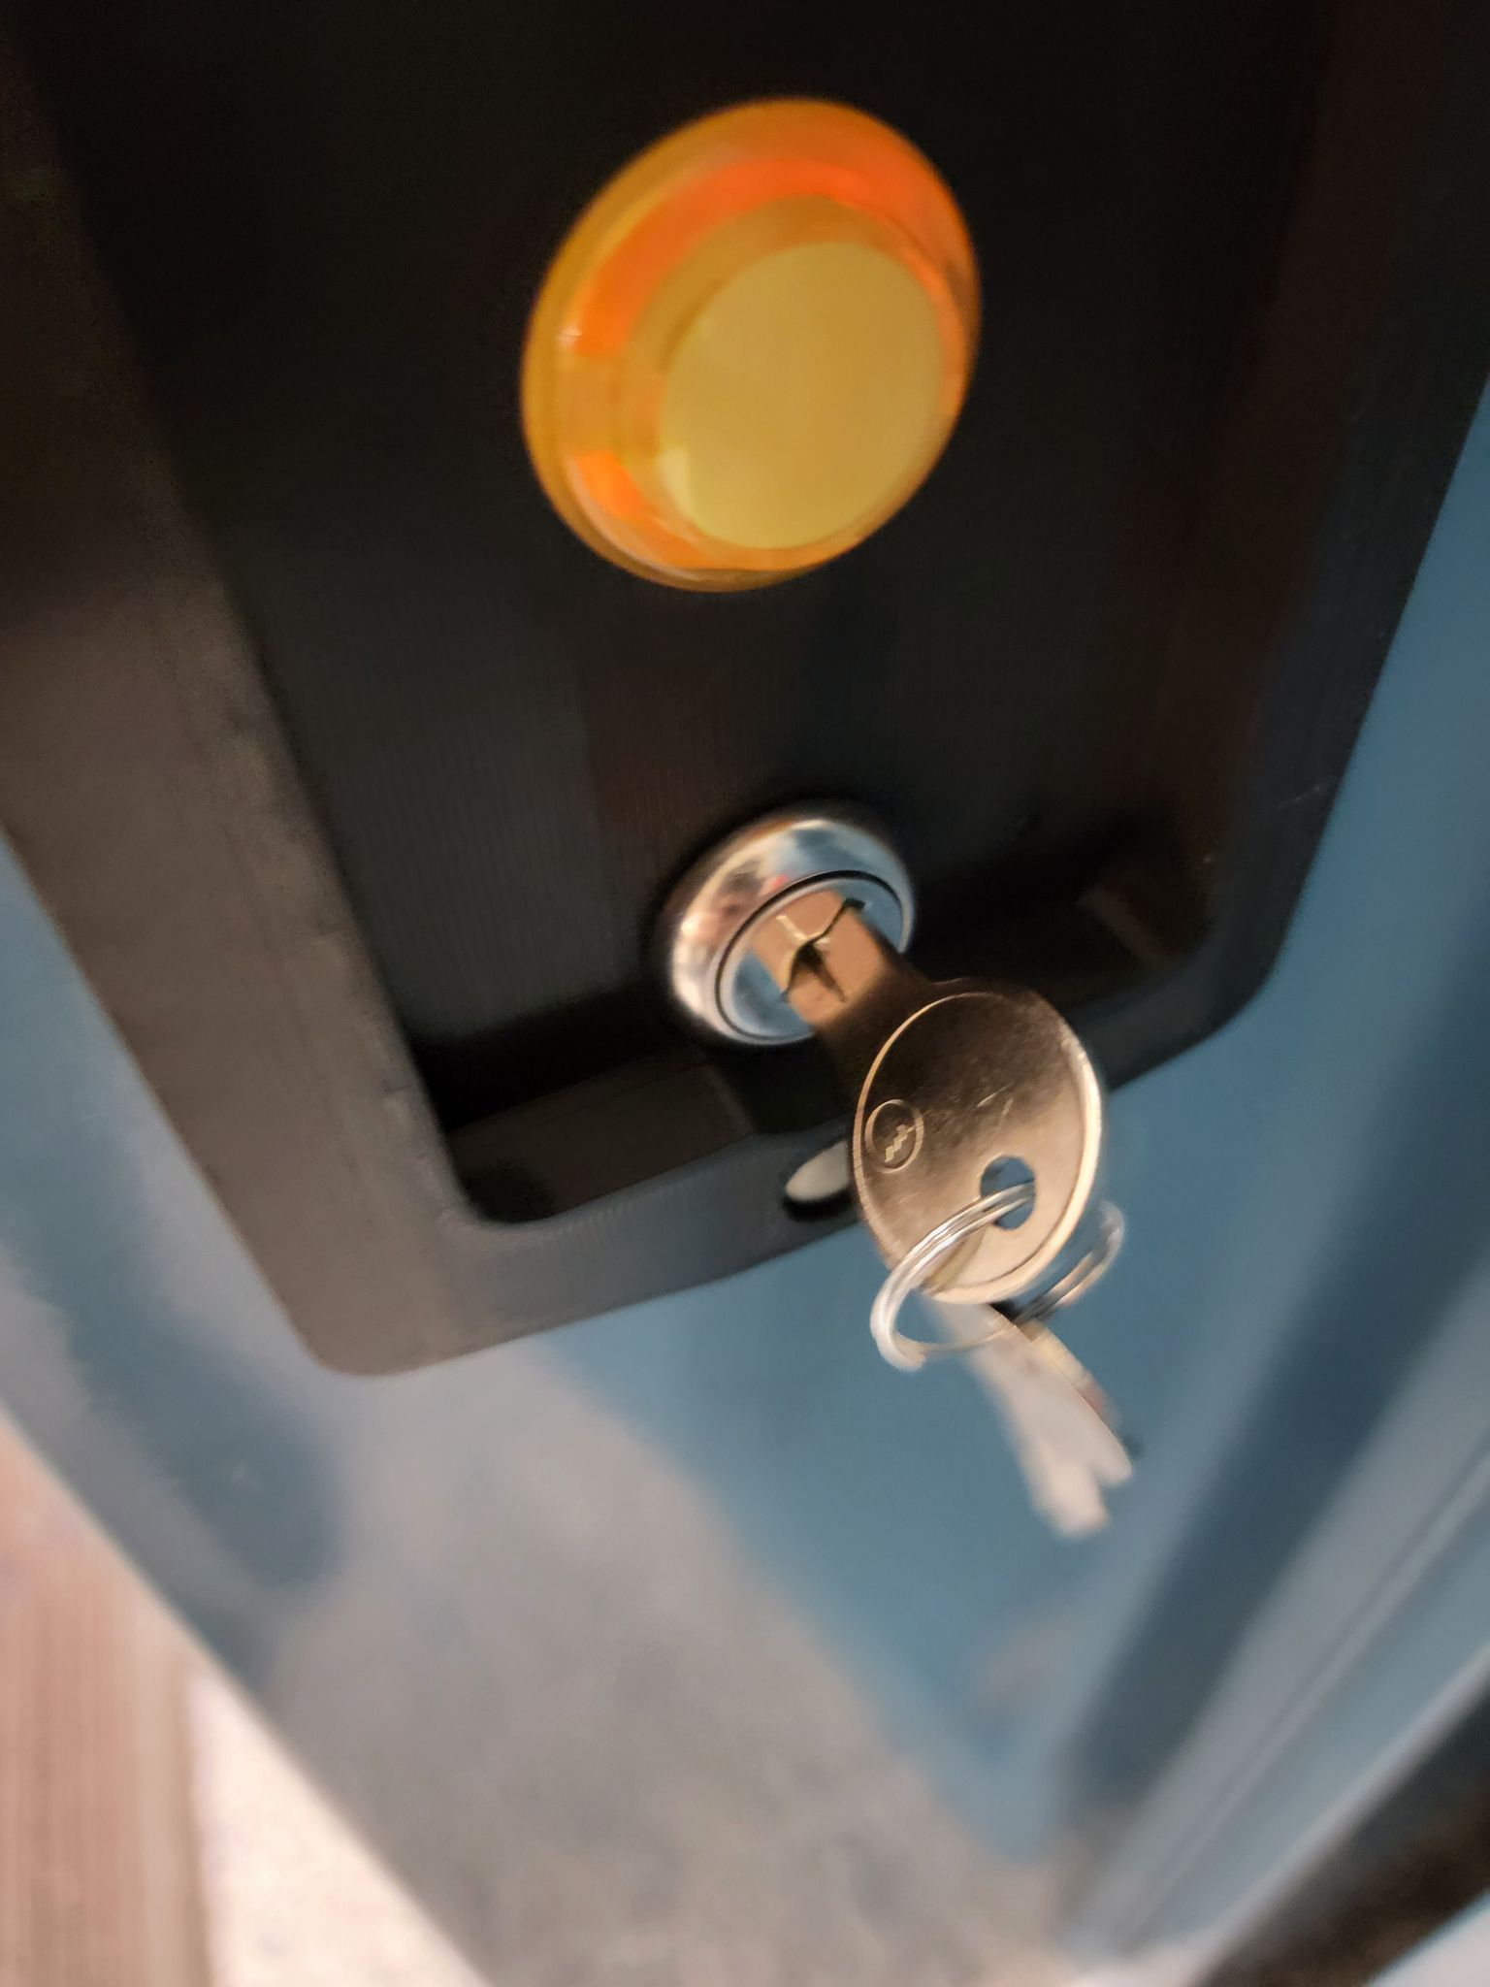

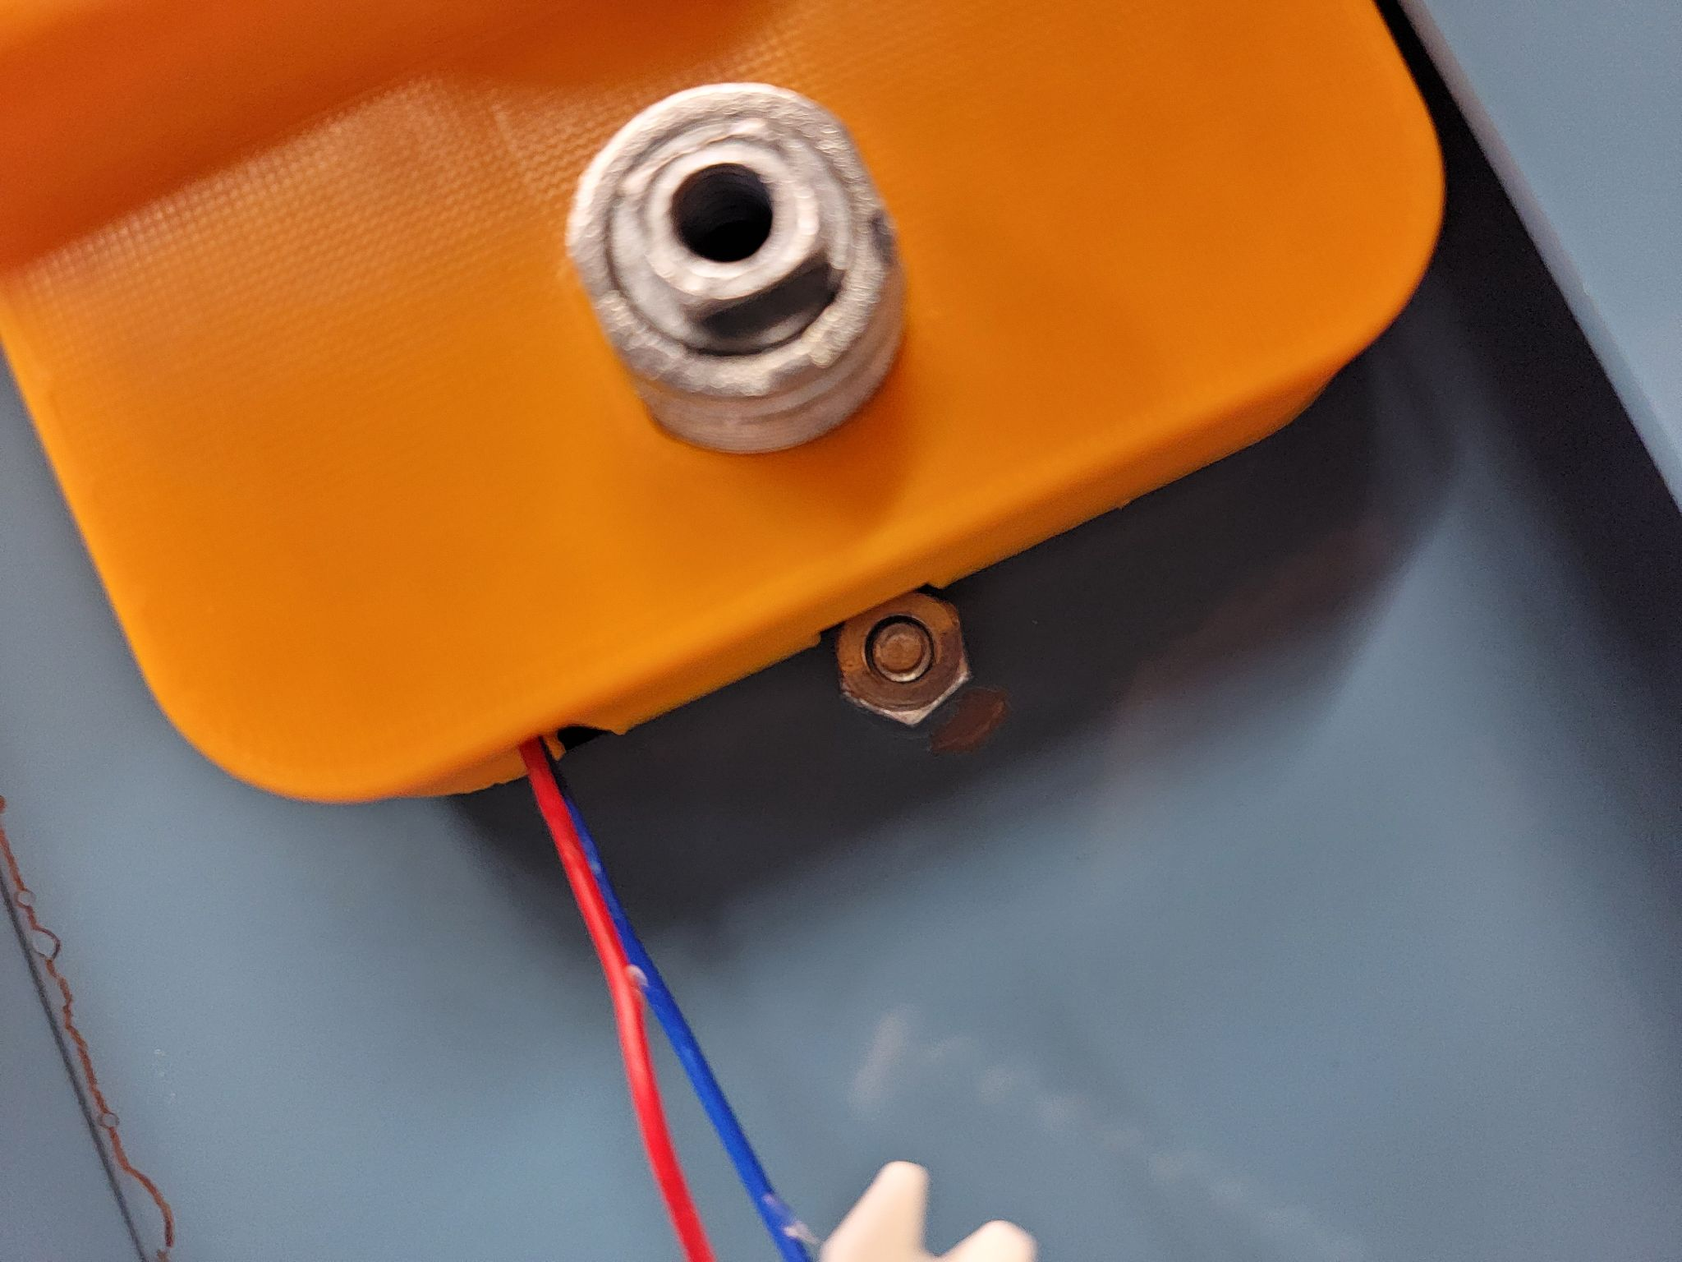

1. The cabinet lock should look like this and should hold the locker insert and the case in place. 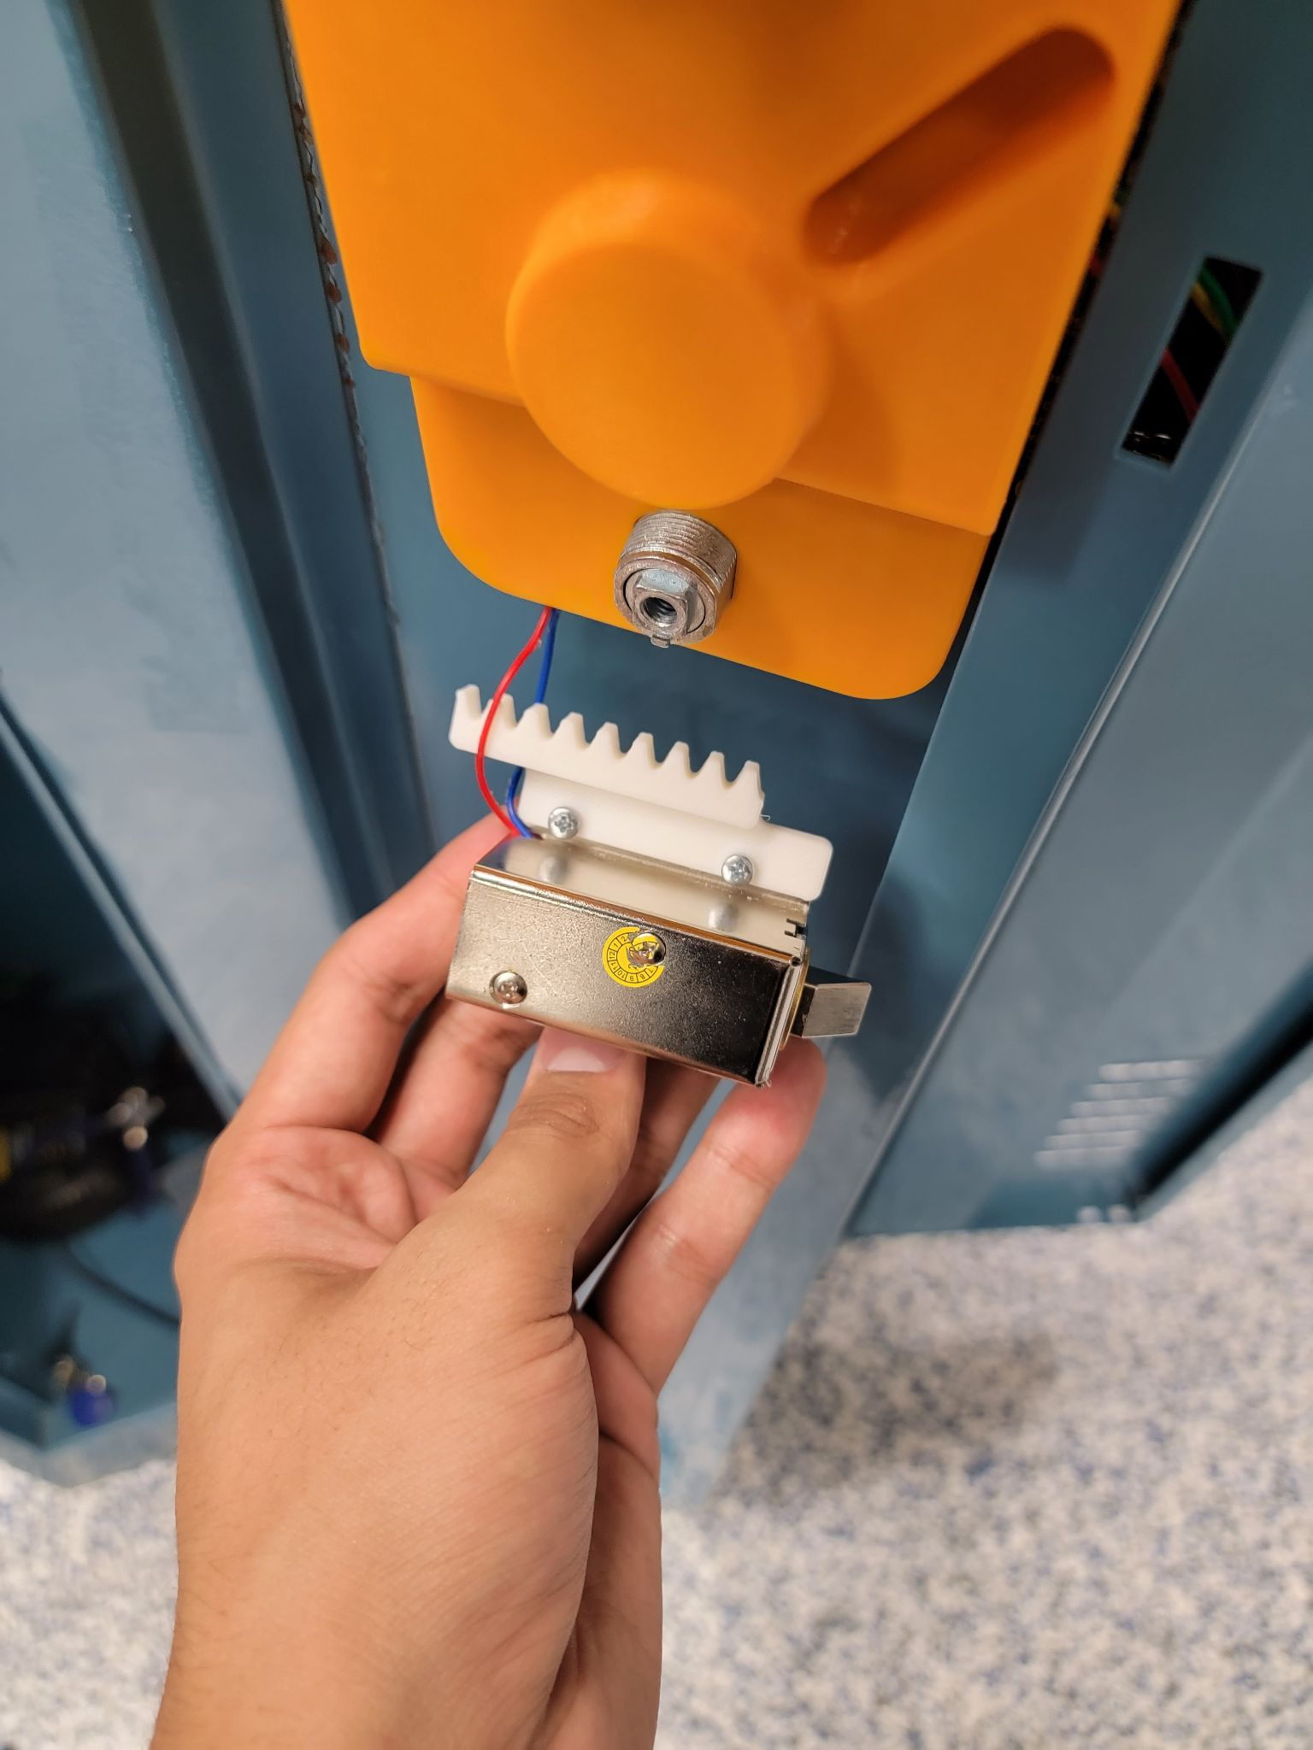
2. At this point, you should insert the battery to the mount and press the button on the outside of the locker to ensure that the circuit works as intended. If not, remove the battery and open the case up to make sure all the wires are connected as intended. Once you have a functional system, you can implement the mechanical override. To do that, make sure you do step 18 first. Then you take that solenoid bracket and put it on the cabinet lock as shown on the right. **Note: You will need to partially pull out the cabinet door from the other end for the bracket to fit as shown.**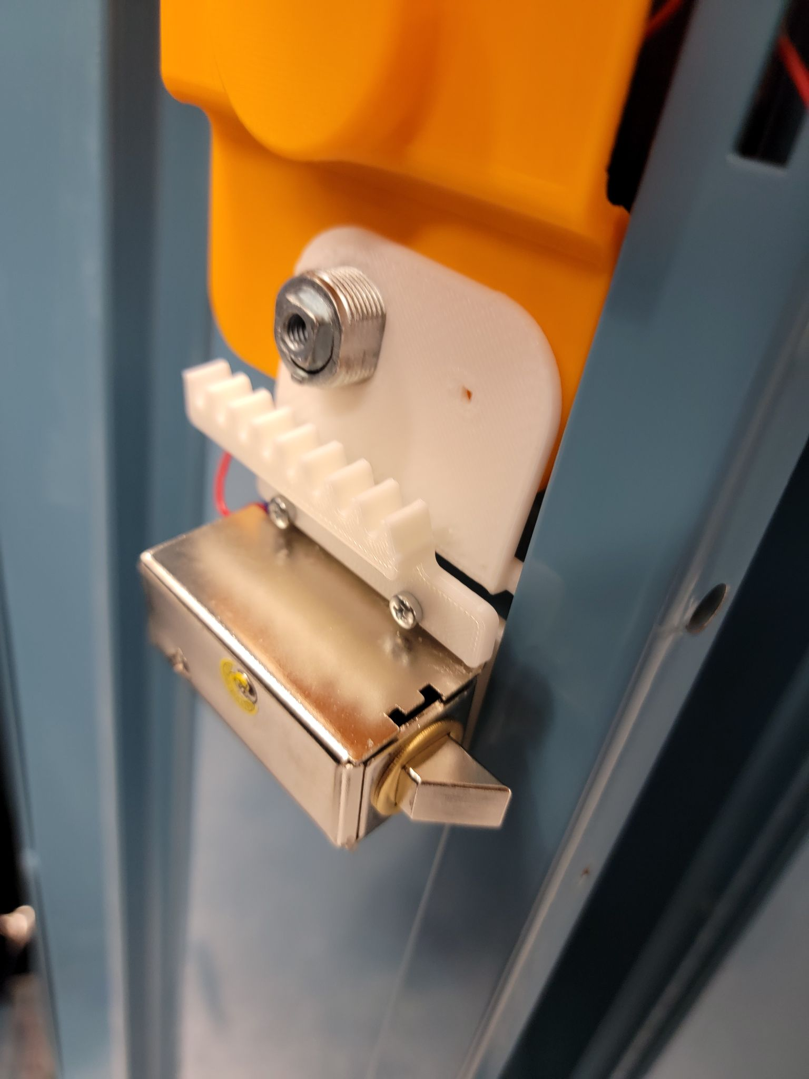
3. At this point, the locker insert case and the insert should feel very secure and in place. Next thing to do is add the 90 degree rotation washer as shown on the left and then carefully add the gear on top of it as shown on the right. Make sure the washer is still in place when you do that. 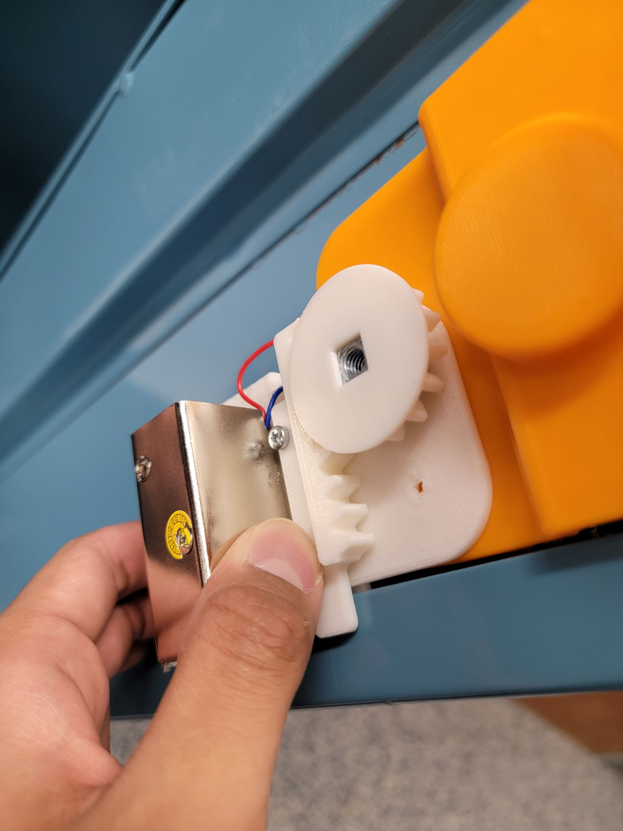

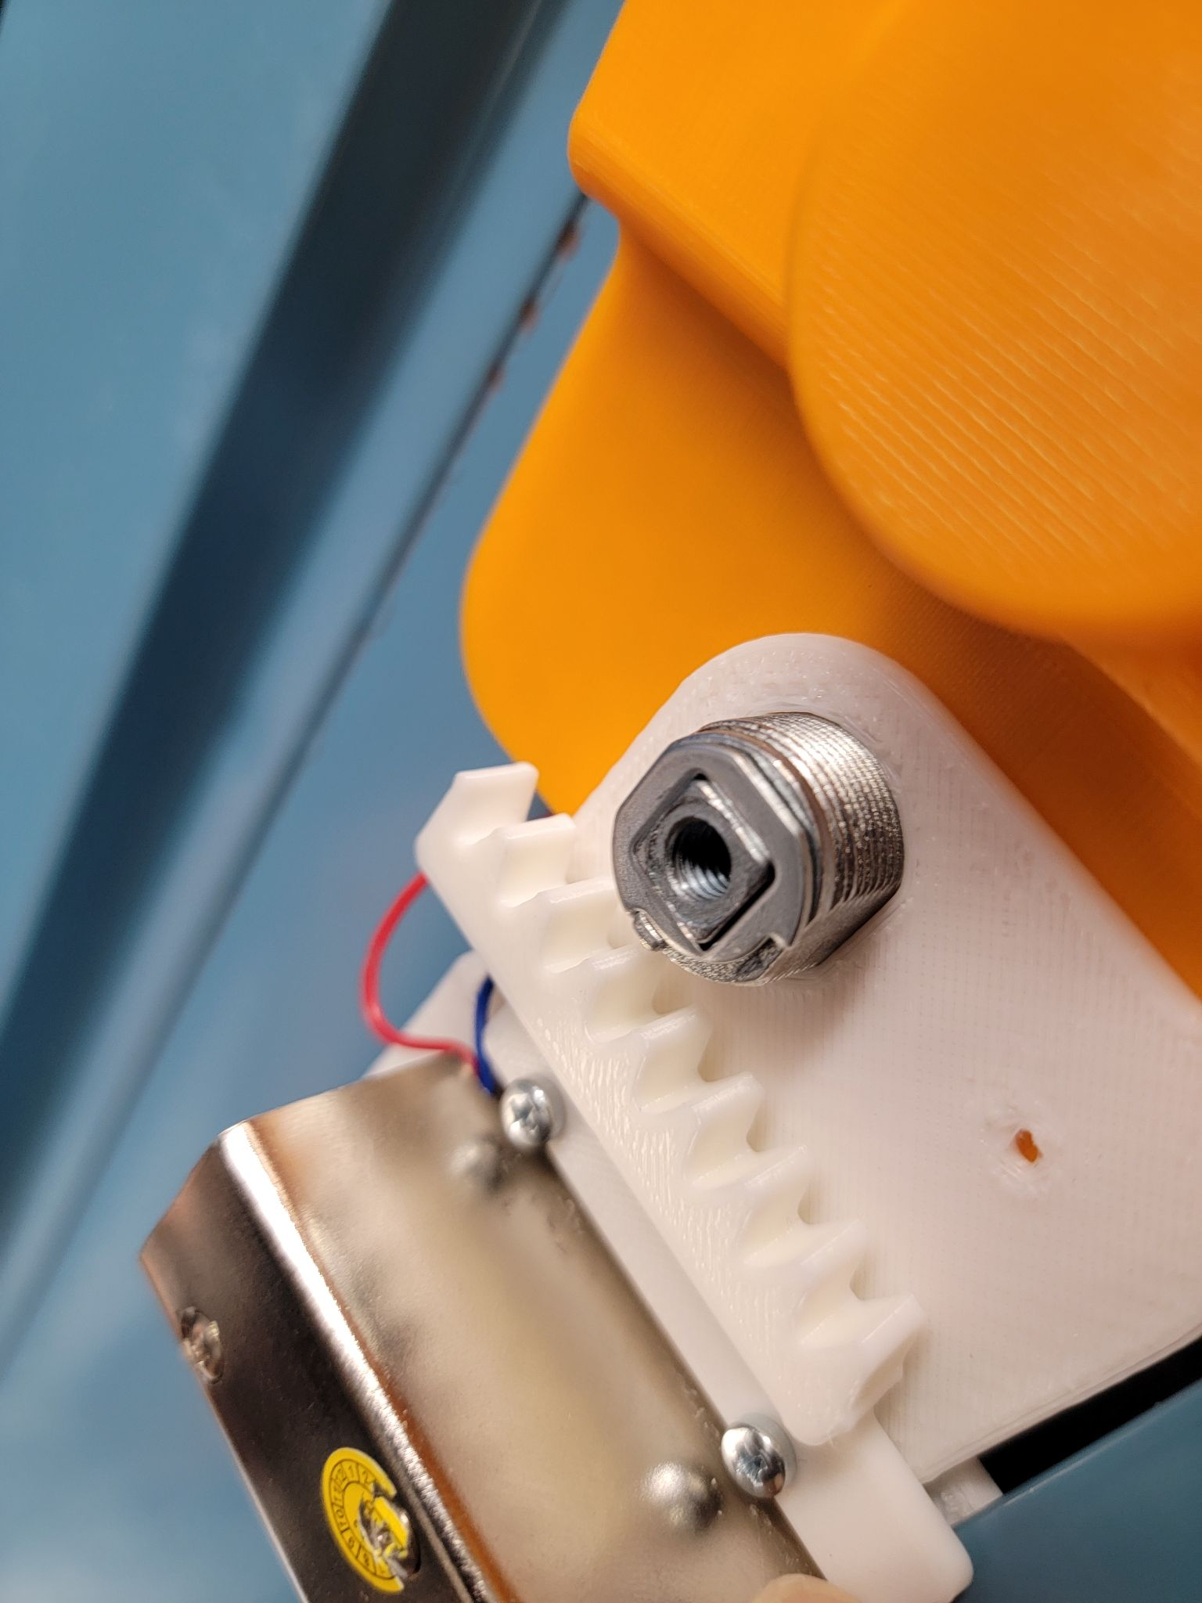

1. After that, you can add a screw to it like the picture on the left below. Right next to the gear, there is a small hole for a screw. Use a small pointy screw to make a hole through the locker insert case. This ensures that the solenoid as well as the bracket is intact and in place. The finished product should look something like the picture shown on the right below.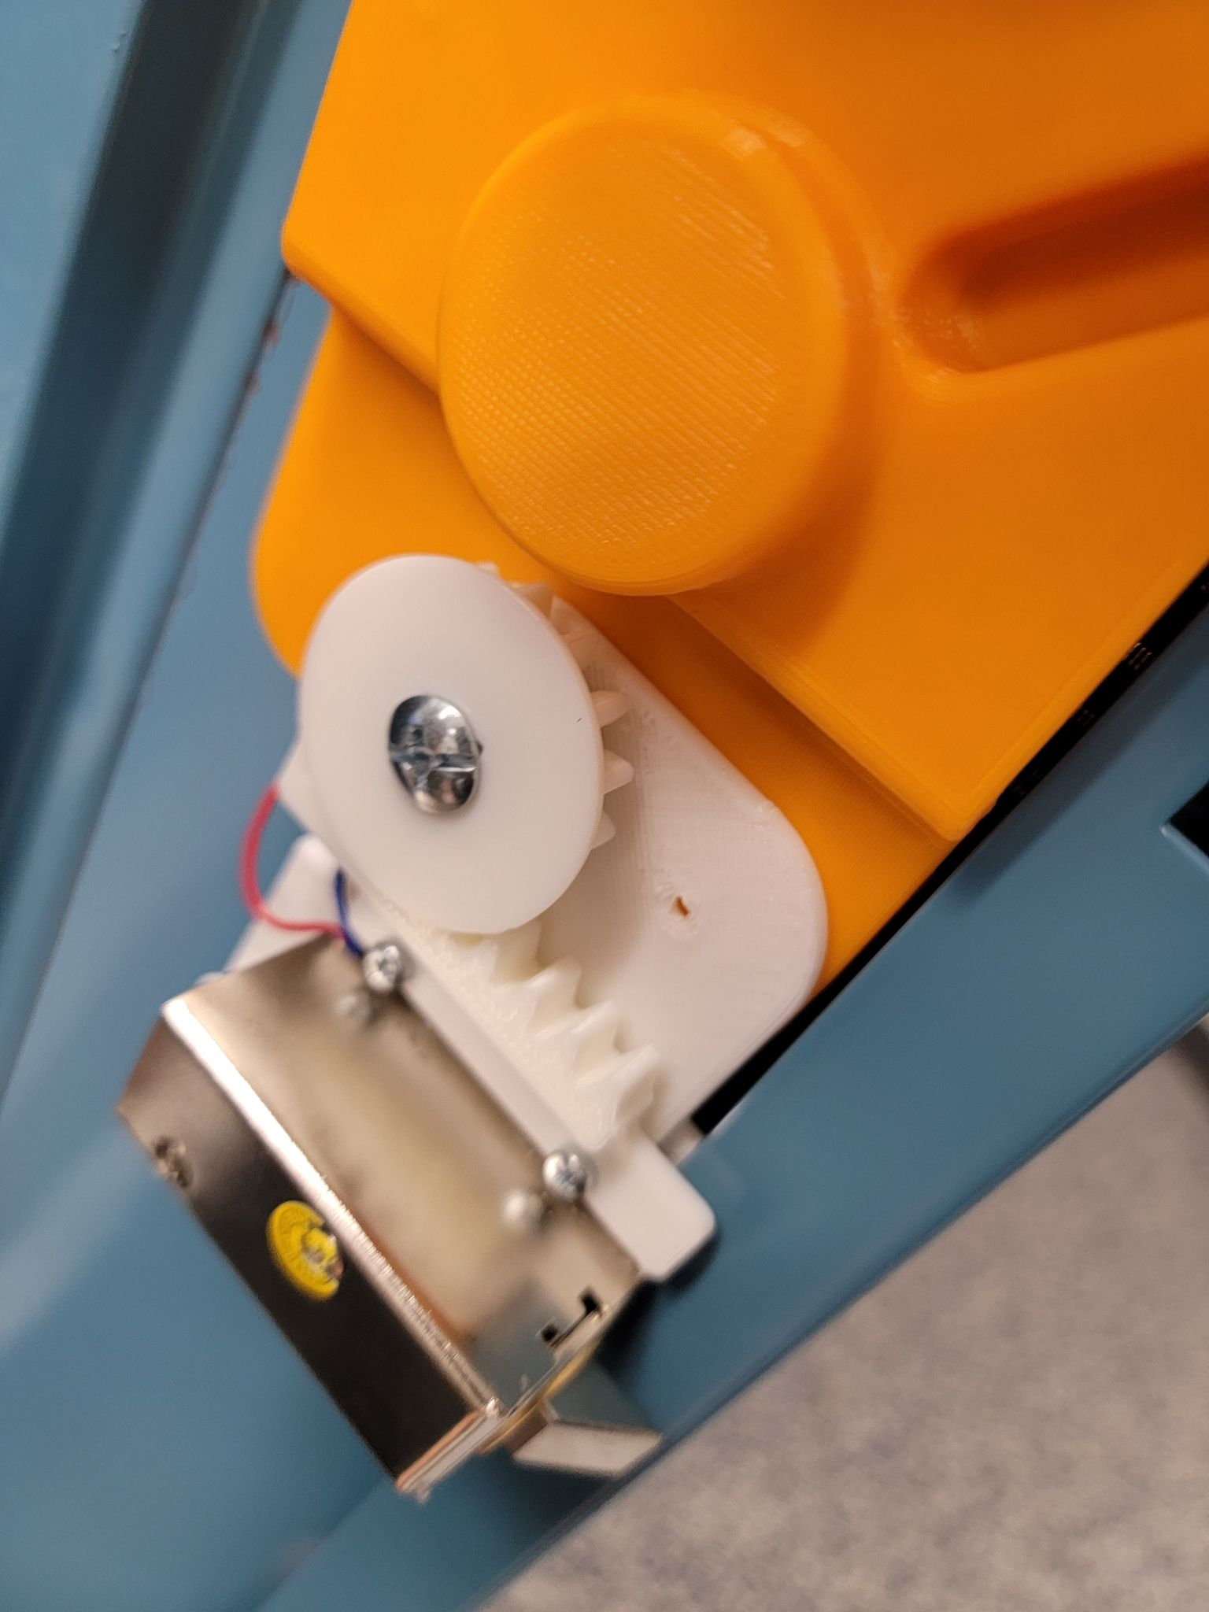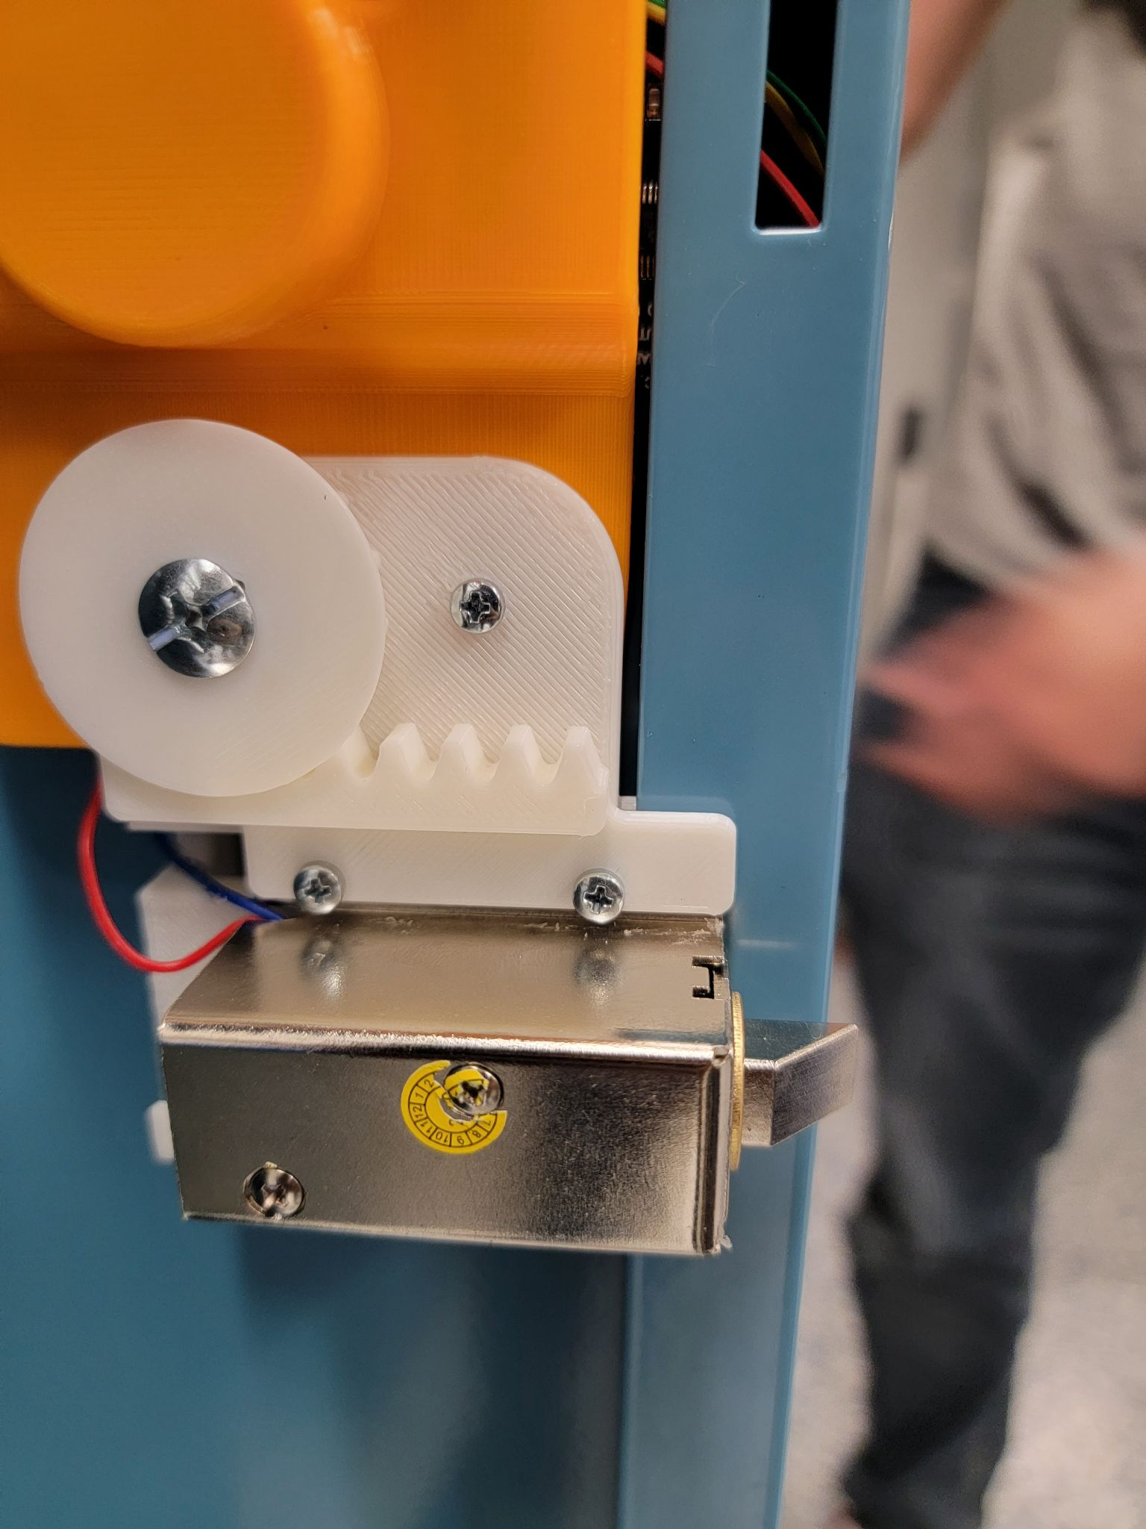
2. At this point, your locker should be fully functional. This step is optional as it adds the push-to-open feature which can be added based on the student’s physical needs and preference. You take the magnetic push latch, as shown in the picture on the left, and tape it down at the bottom of the locker using the double sided tape provided in the package of the latch. Put it appropriately 3.5 cm or 35 mm from the edge of the locker. It should look like something shown in the picture on the right.

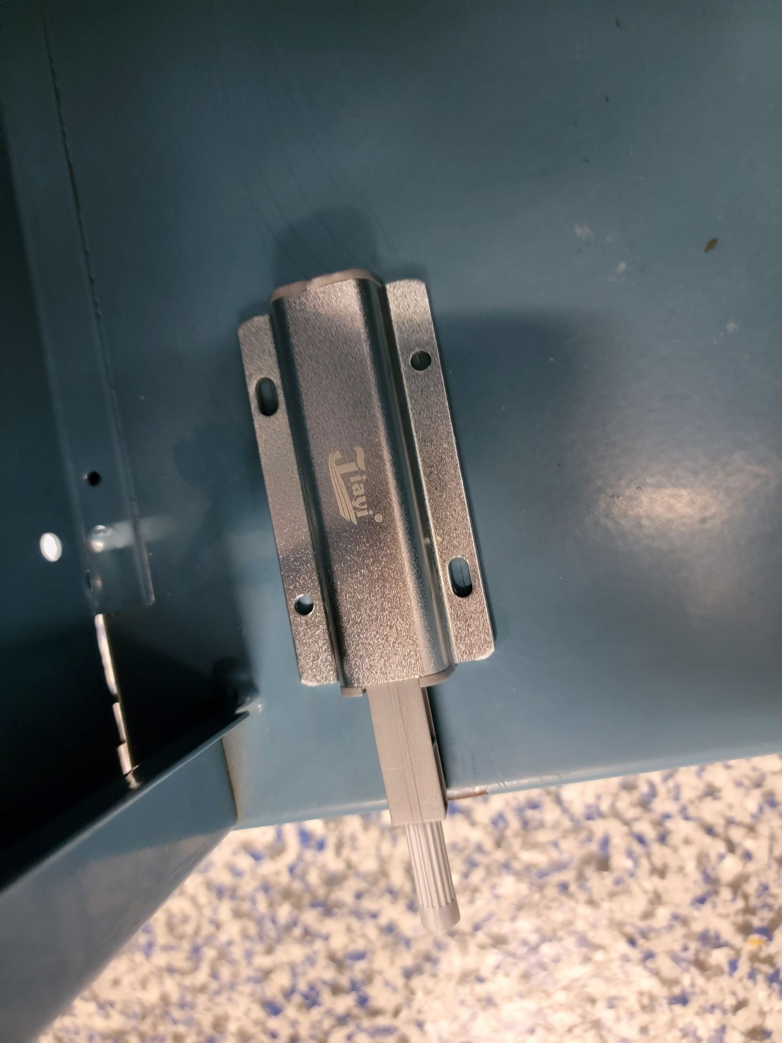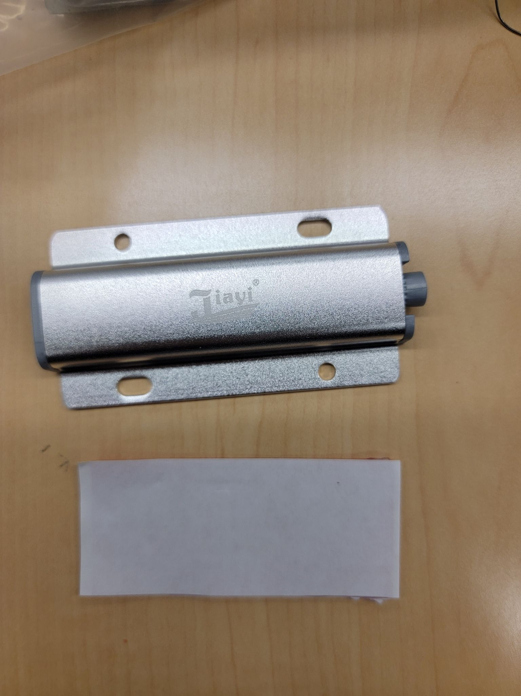

You should now have a fully implemented locker. Place the locker in a secure location, perhaps having the back of the locker against the wall. It is now ready to use.